Mobile Apps with Expo – Exercises
Exercises and homework assignments for “Full Stack Apps with AI” course at SoftUni.

BMI Calculator Mobile App
In a new workspace, build a BMI Calculator (Body Mass Index Calculator) app using React Native and Expo:

Initializing an Expo Project
In a new workspace, use the VS Code Terminal and run the "npx create-expo-app bmi-app" command.
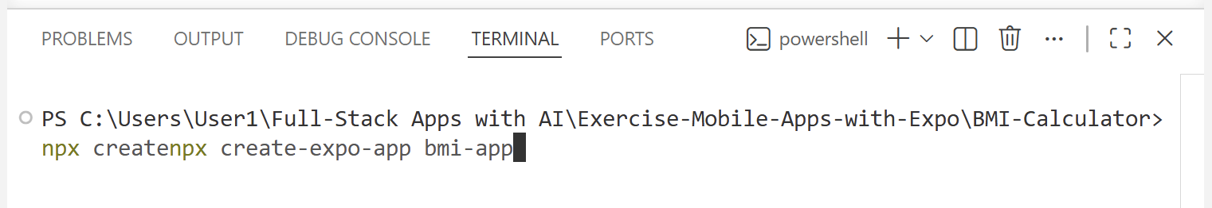
The result should be template files which will be further configured:
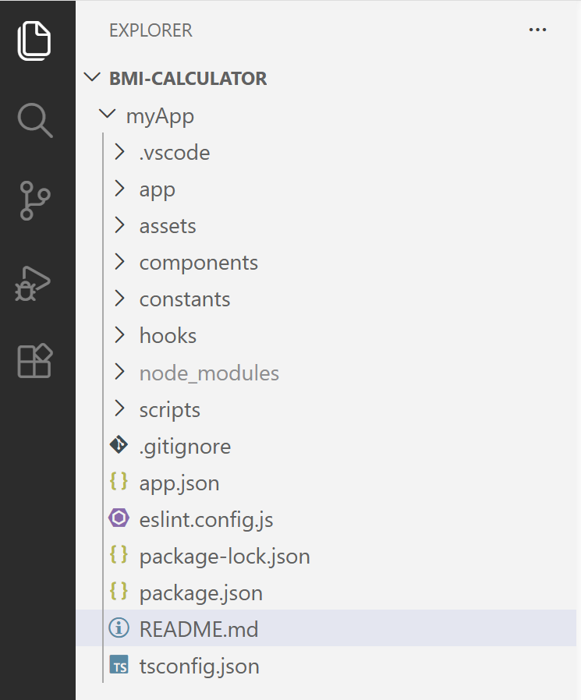

Building the App
- Enter weight and height, calculate the BMI, and display the BMI value
- Show the BMI category based on the result:
  - Underweight: BMI < 18.5
  - Normal weight: 18.5 – 24.9
  - Overweight: 25 – 29.9
  - Obesity: BMI >= 30

Sample AI Prompt
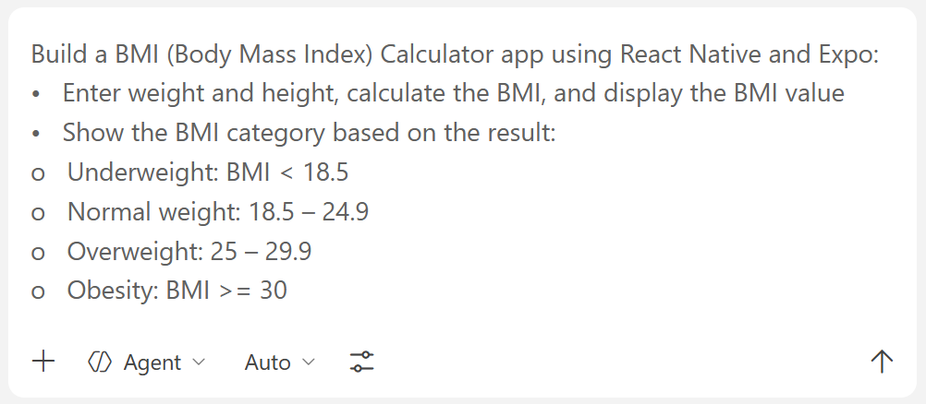

The Result
Note: For the next steps, it’s very important that your PC and smartphone are connected to the same WiFi.
In the VS Code Terminal, run the "npx expo start" command:
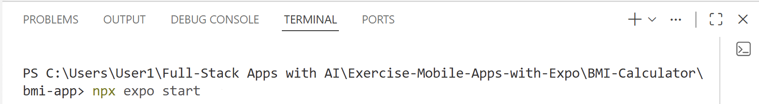
On the Terminal you will see a local server and a QR code:
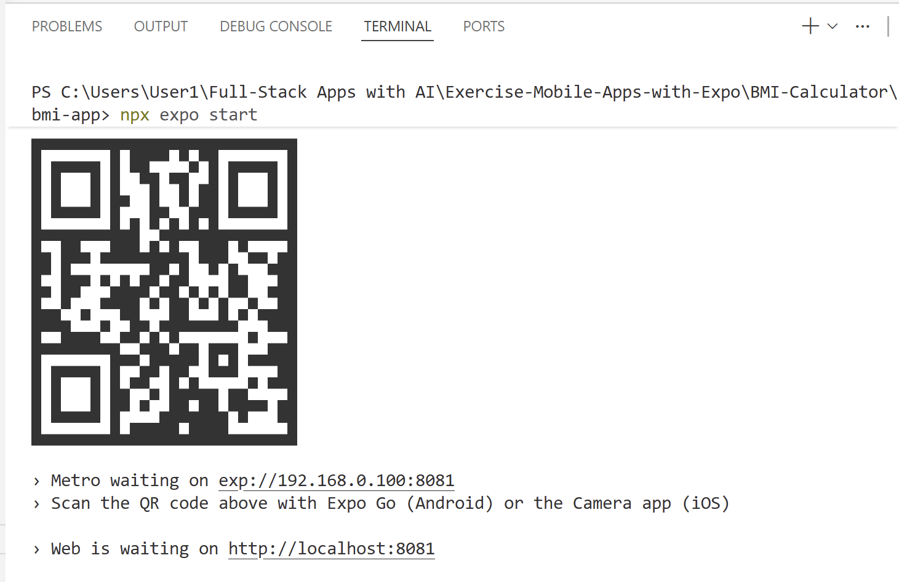
To open the app in the browser, click the link to the local server.

The App in the Browser
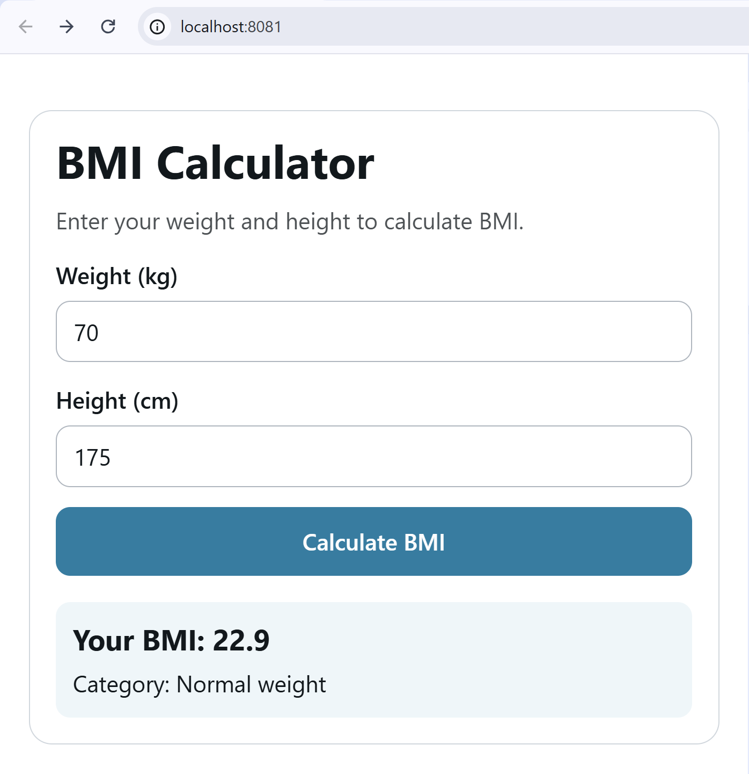

Install Expo Go
To test the app on a mobile device, install Expo Go from Google or Apple Store. Create a free account:
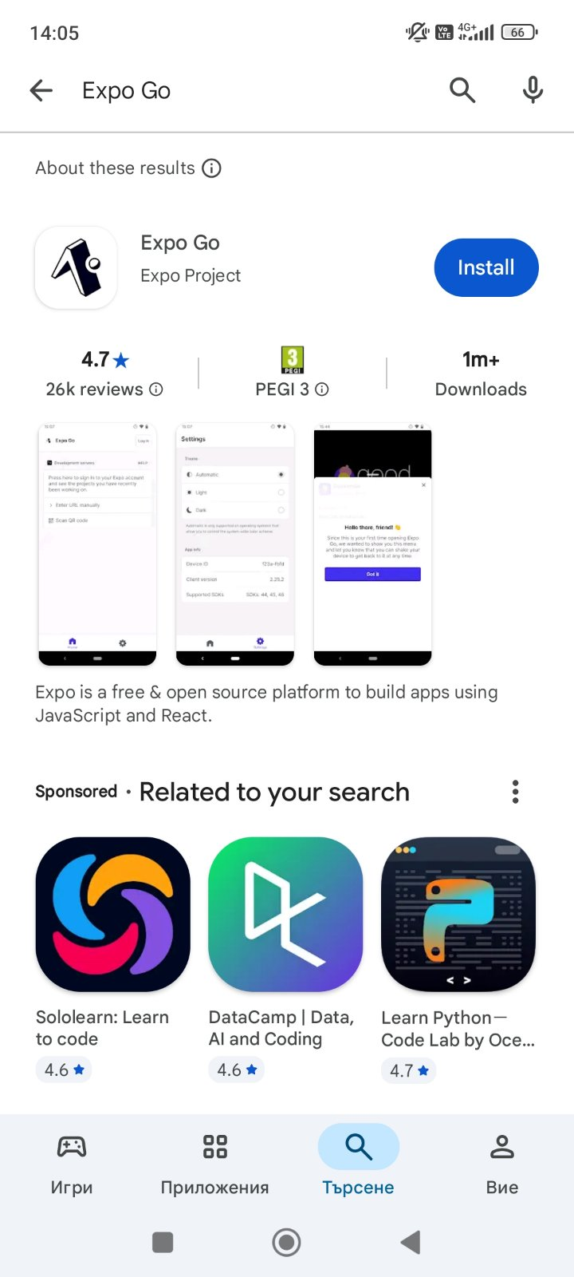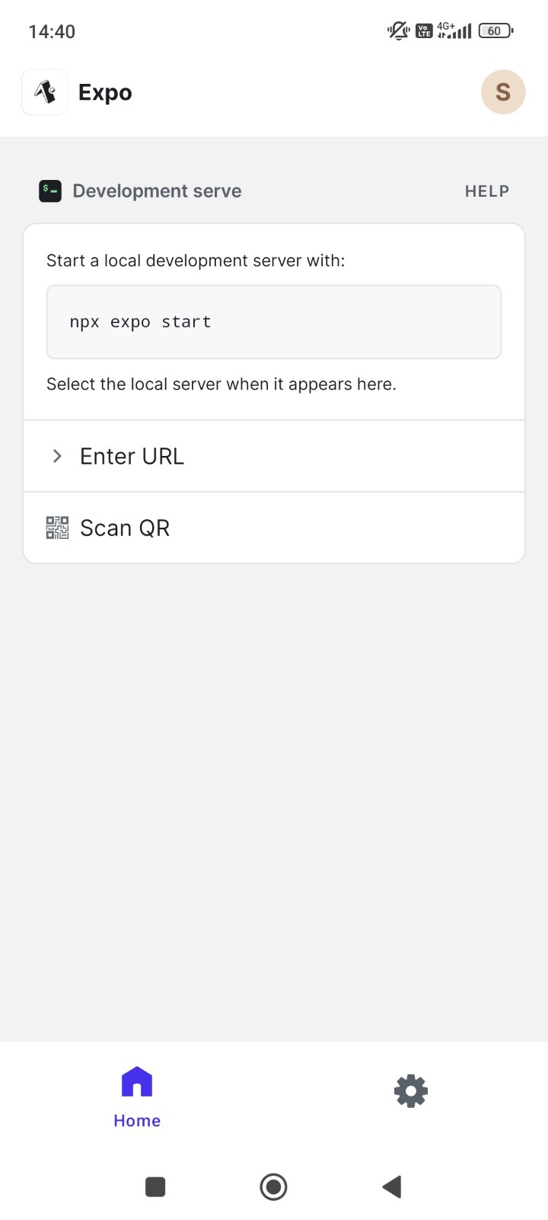

The App on a Smartphone
To run the app on your smartphone, scan the QR code from the Terminal with Expo Go. Here is how the app may look on a smartphone:
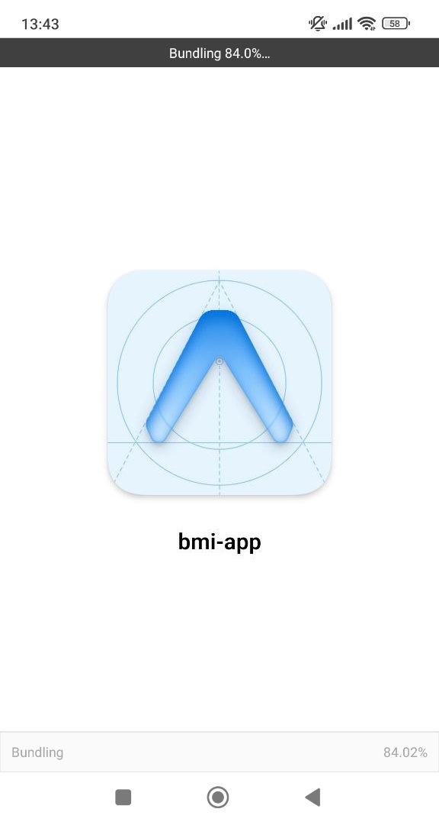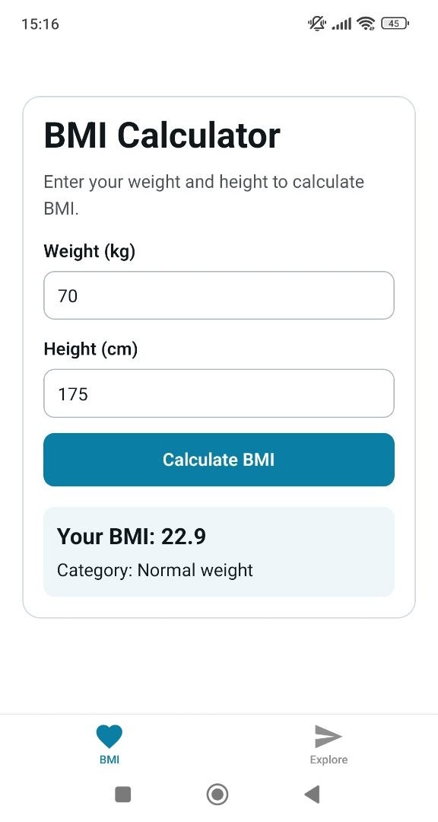

Common Errors and Solutions

Error 1: Different Internet Sources
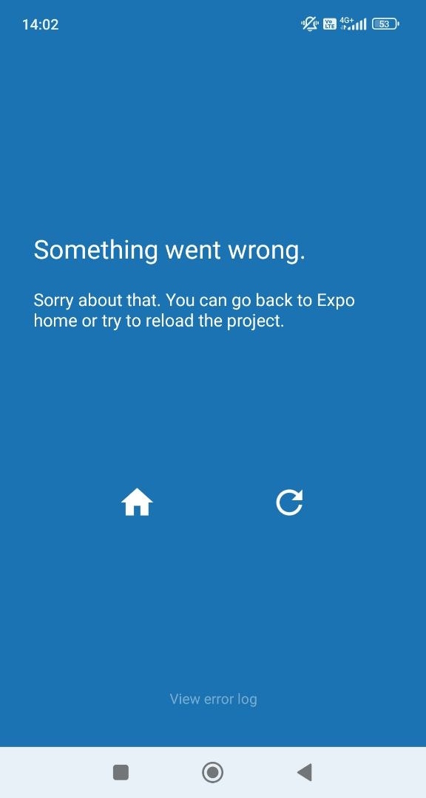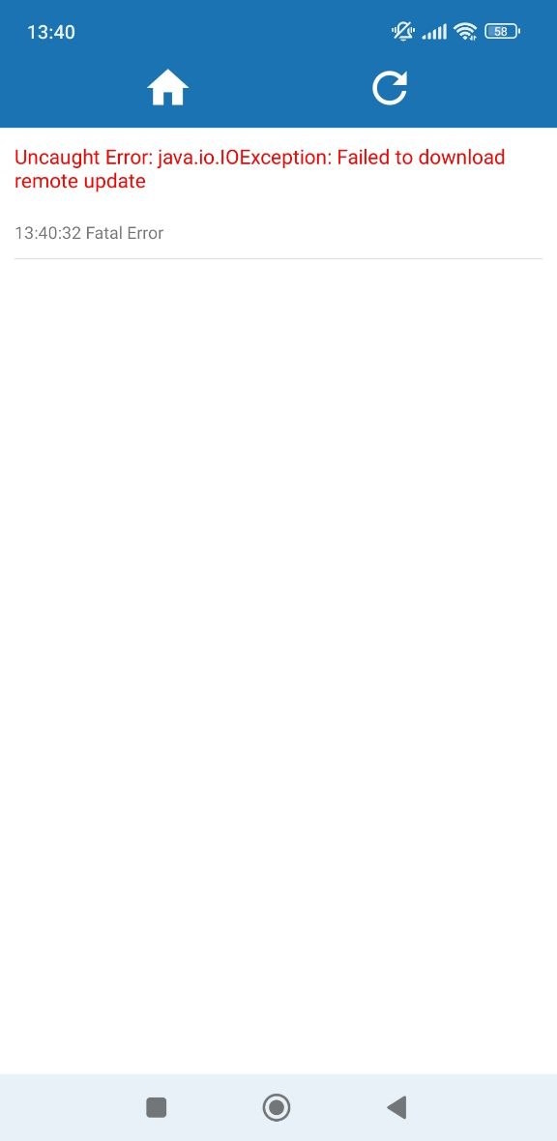

Solution
Set the Wi Fi for your PC and smartphone to be the same, then stop the current server with [Ctrl] + [C]. Run the "npx expo start -c" command which starts the server again and clears the cache from the previous try:
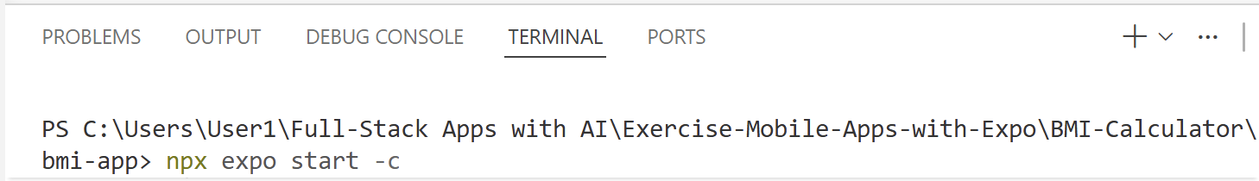

Error 2: Version Mismatch
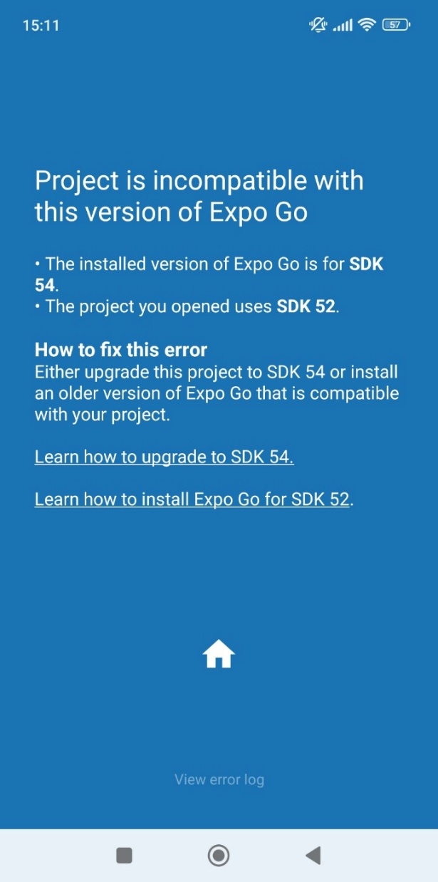
This error shows that the project Expo version is different from the one in Expo Go.

Solution
Check the project version in VS Code. Open the package.json file. Then look up in the "dependencies" and the "expo" version. In the case below, it’s 52.0.00:
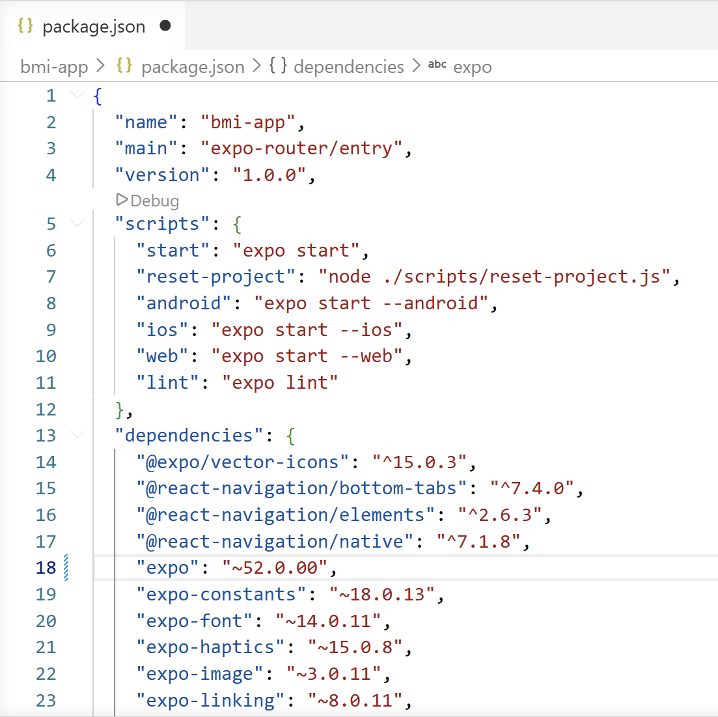
Change it manually to the one needed. In the case below this is 54.0.33:
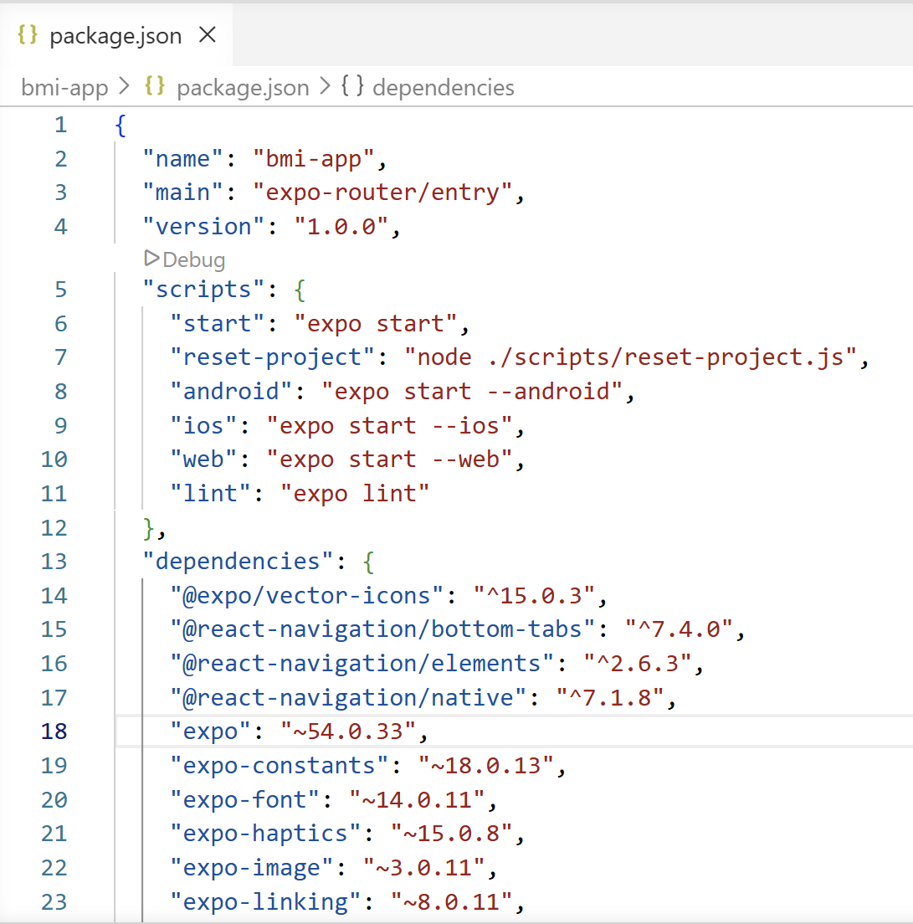
Run "npm install" to install the correct dependencies, then "npx expo install –fix" to sync with Expo React, React Native and all Expo packages. Then run the "npx expo start -c" command which starts the server again and clears the cache from the previous try.

Error 3: Broken / Inconsistent Dependencies
Even after running the commands above, there may still be some issues which are hard to find. You may get the following error when scanning the QR code:
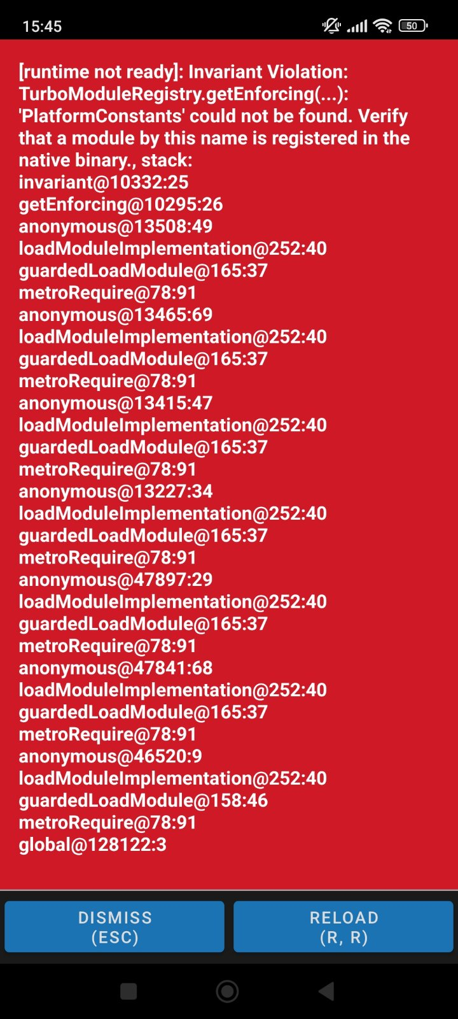

Solution
Close VS Code and open the folder with the files on your PC. Delete the "node_modules" folder and the package-lock file:
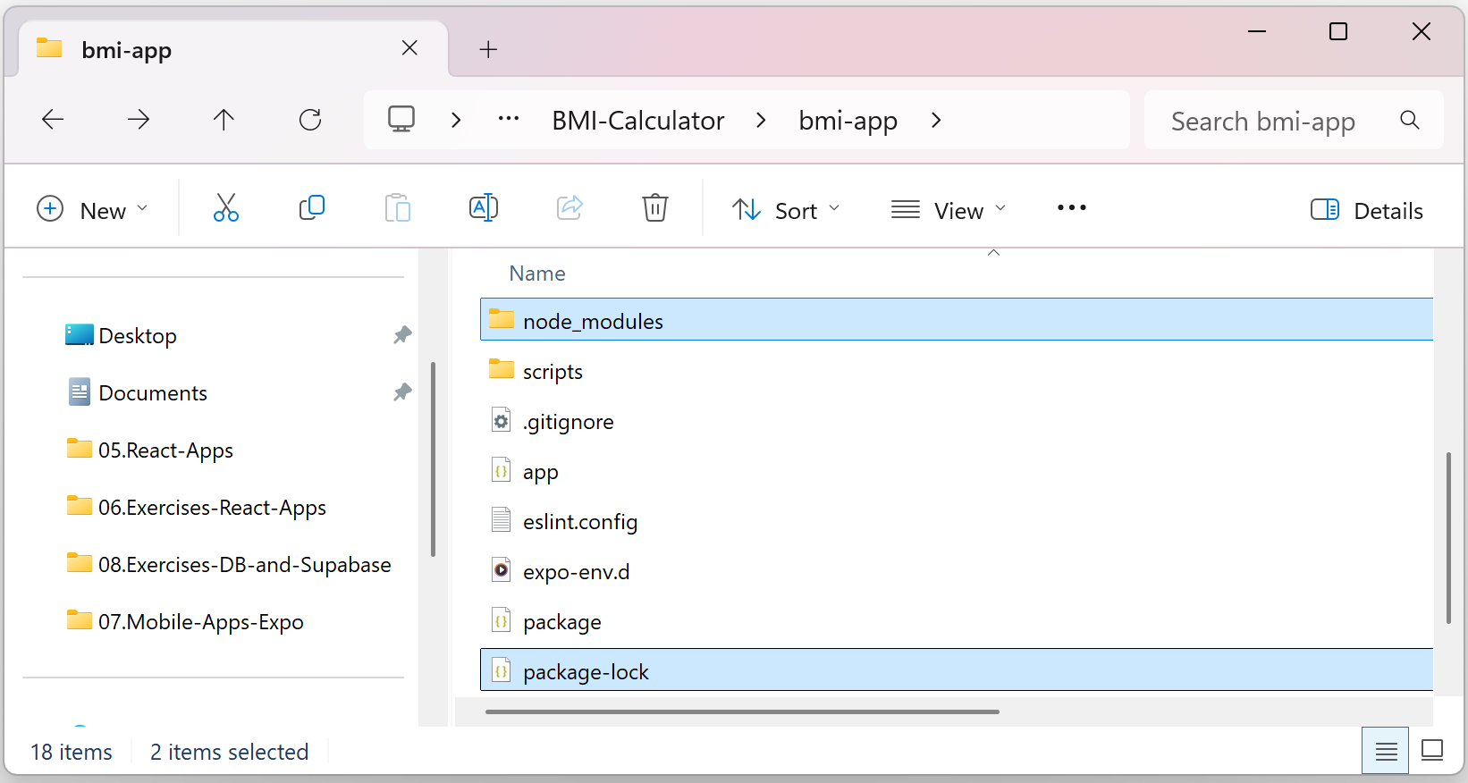
Open the project in VS Code again and run the "npm install --legacy-peer-deps" and "npx expo start -c" commands.

Unit Converter Mobile App
In a new workspace, build a unit converter mobile app, using React Native, Expo and Expo Router:
- Home screen: display intro text + Metric Converter icon + Temperature Converter icon
- Metric Converter screen: implement metric converter (mm, cm, m, km, inch, foot)
- Temperature Converter screen: implement temperature converter (Celsius, Fahrenheit)

Initializing an Expo Project
In a new workspace, use the Terminal and run the "npx create-expo-app unit-converter" command.

Building the App: Sample AI Prompt
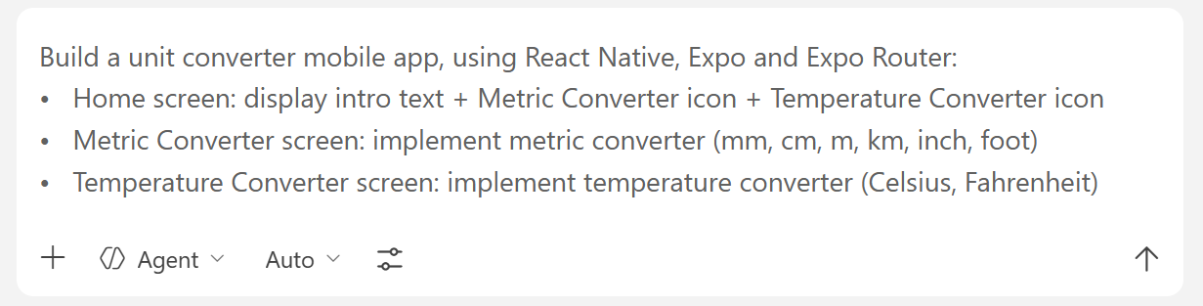

The App in the Browser
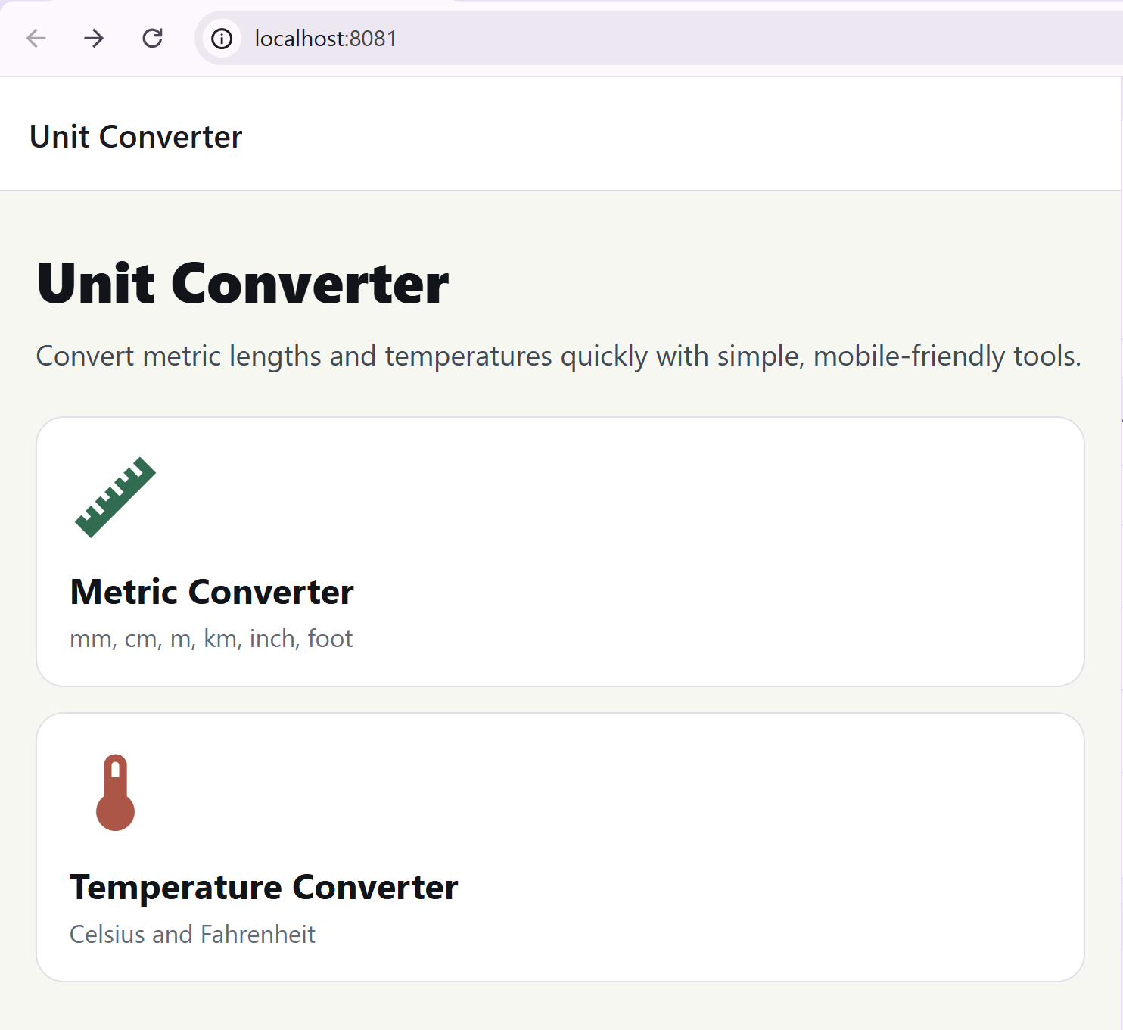

The App on a Smartphone

The Home Screen
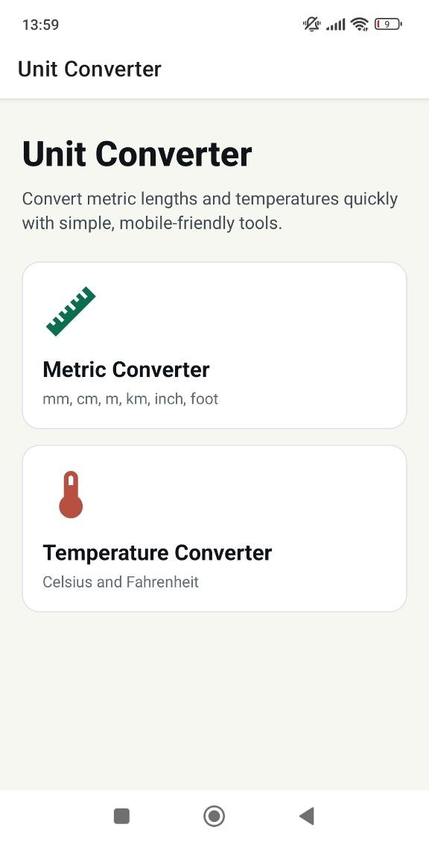

The Converter Screens
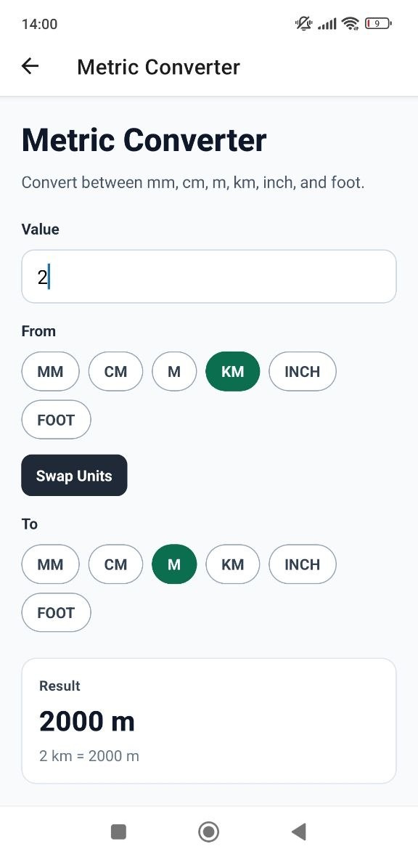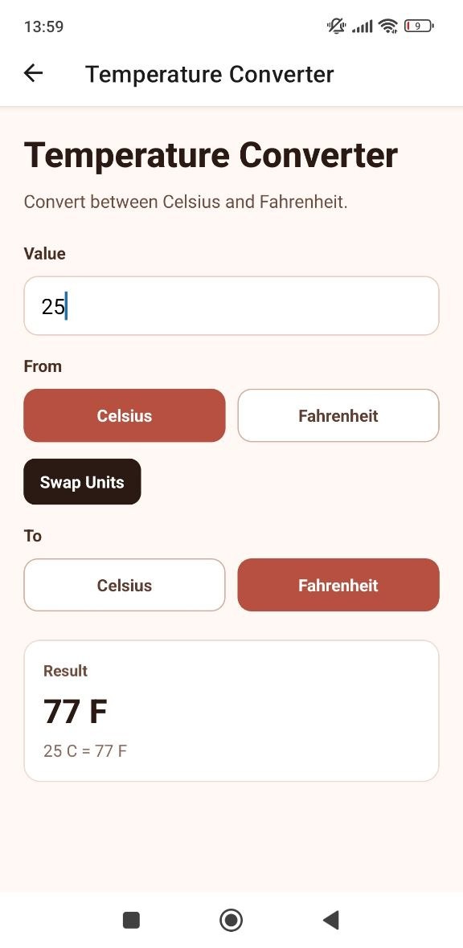

Bookmarks Mobile App
Build a mobile app with Expo to keep user bookmarks in Supabase:

Step 1: Setup Supabase

Create a Supabase Project
Sign in Supabase and go to your Dashboard. Create a new organization or use the one you already have. Go to Projects and create a new project for the app:
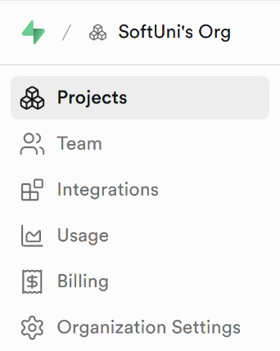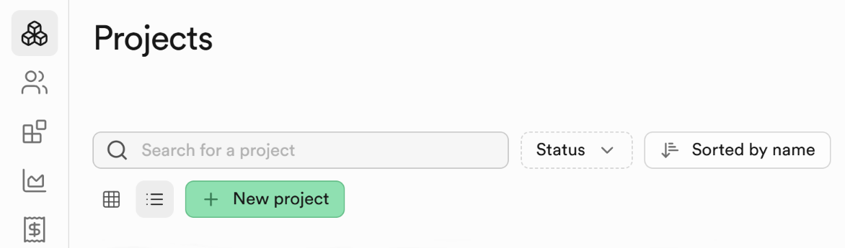
Fill in the necessary details:
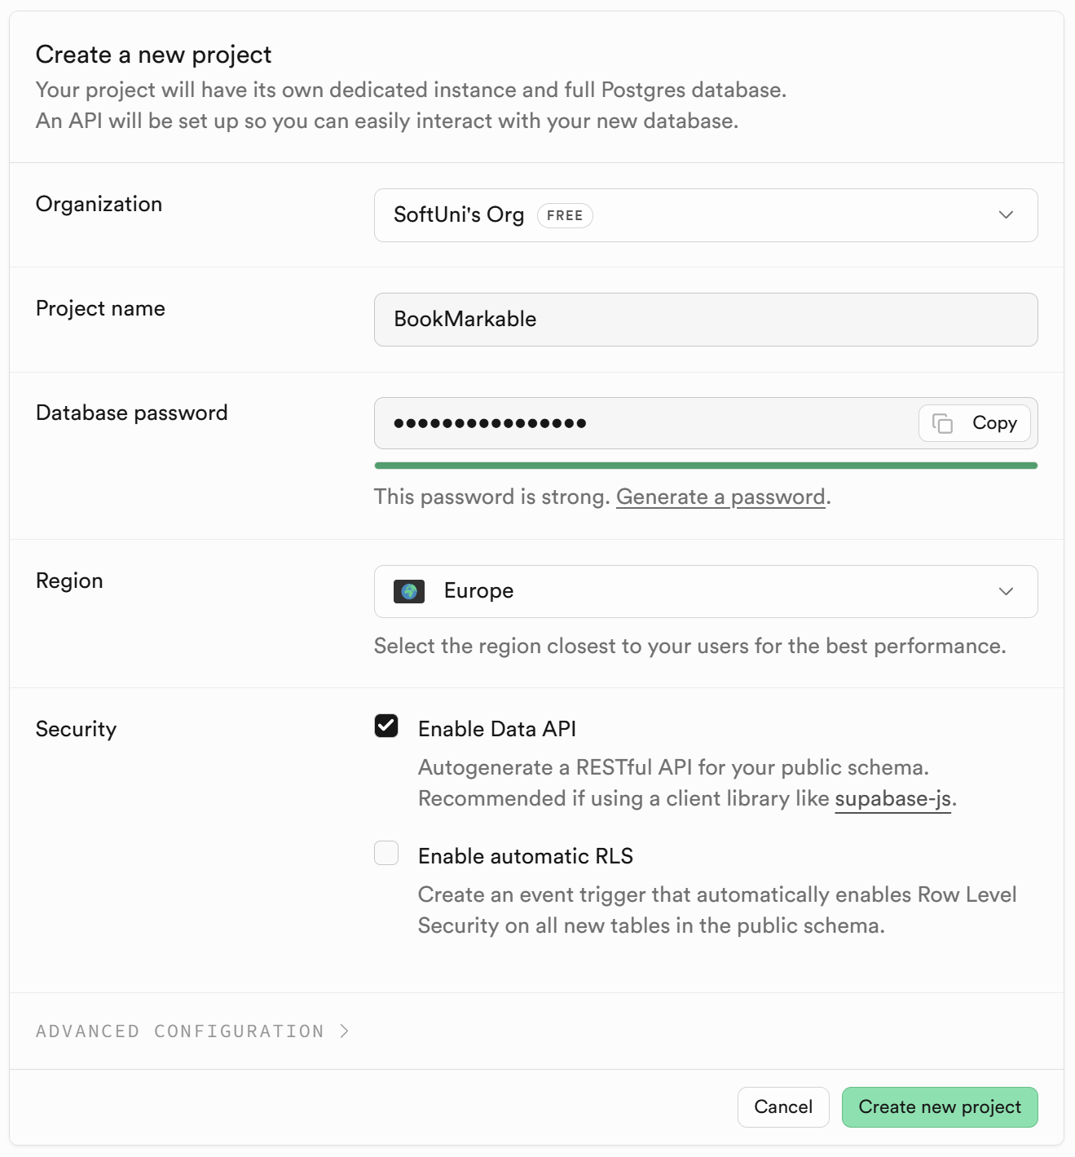

Install Supabase MCP
Go to your Dashboard in Supabase and select Connect, then the MCP tab. From the drop-down menu choose VS Code:
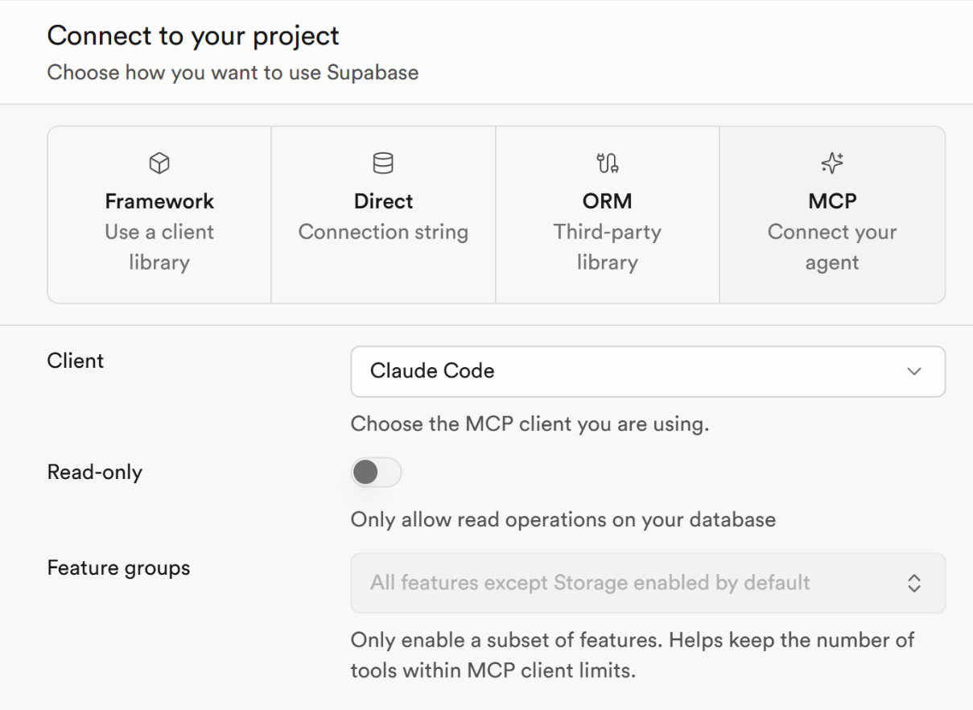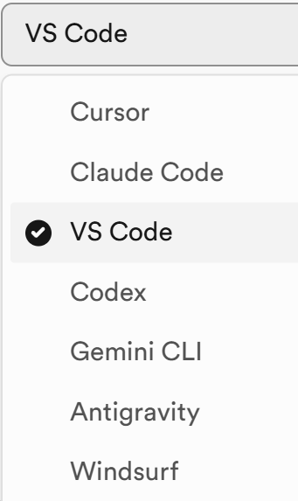
Press the [Add to VS Code] button:
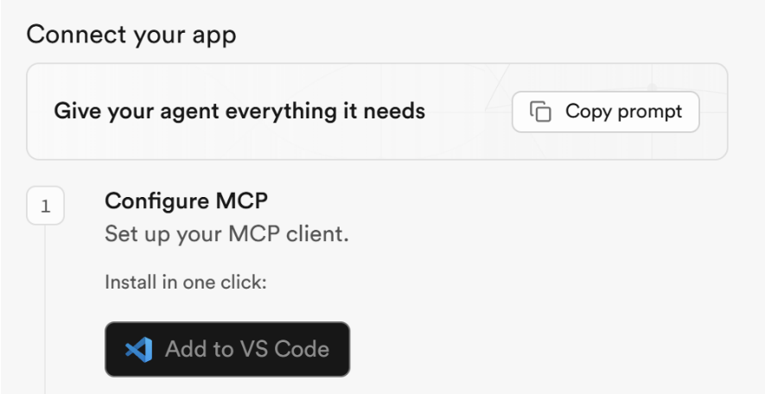
You will be forwarded to Visual Studio Code. Click the [Install in Workspace] button:
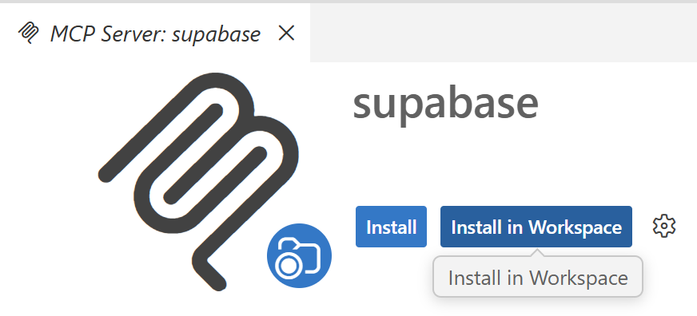
Click [Allow] for the following question:
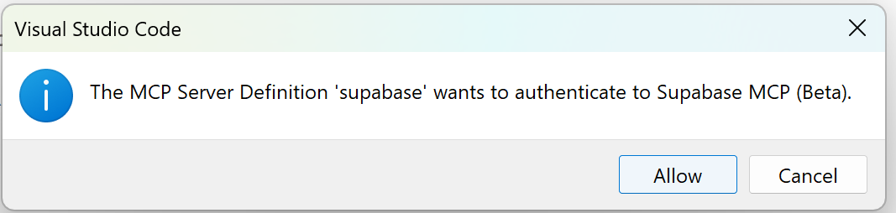
Authenticate the installed Supabase MCP server to your Supabase project. Select [Open]:
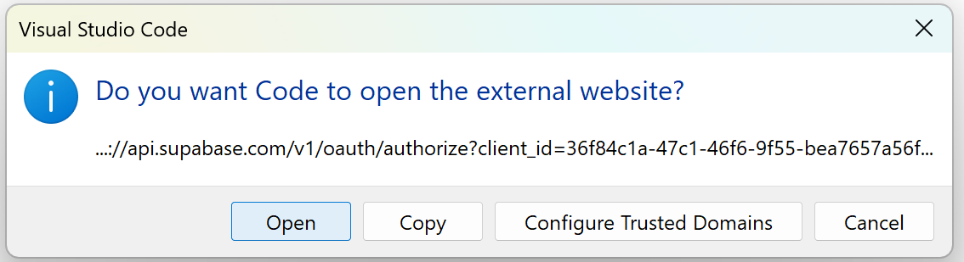
On the page that has opened, select [Authorize Visual Studio Code].

Check Supabase MCP
To check if Supabase MCP is running correctly, open the Chat window in VS Code (the GitHub Copilot chat) and click the settings button [Open Customizations]:
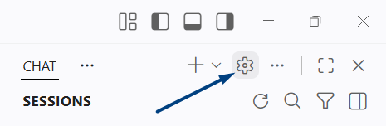
Choose [MCP Servers] tab to see which MCP servers are currently running.
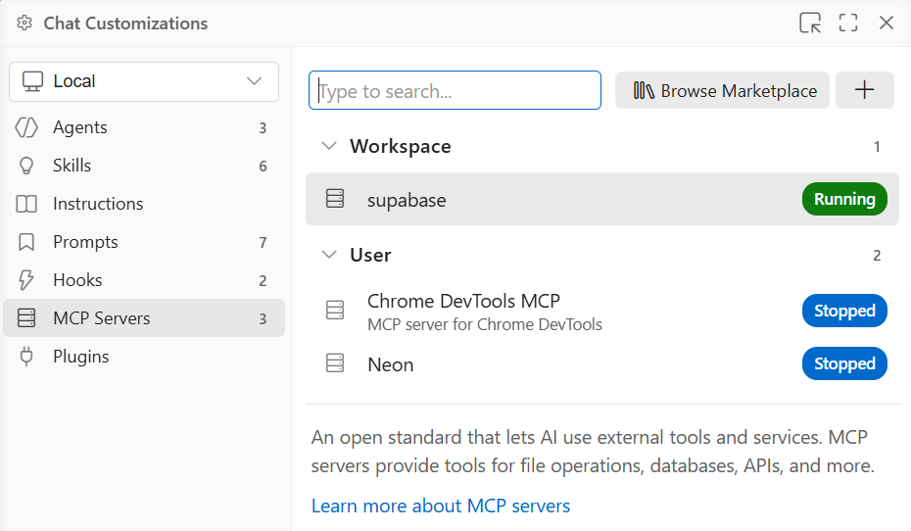
If "supabase" is shown as "Running", this means that Supabase MCP is properly configured, successfully connected to your Supabase project and works as expected.

Disable Email Confirmation
Enable Supabase Auth (email + password), disable "confirm emails". Select [Authentication] from the drop-down menu and then click [Sign In / Providers]:
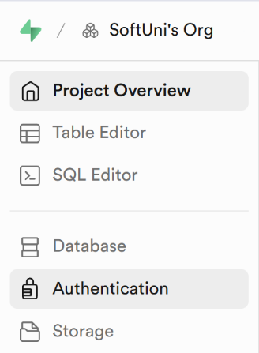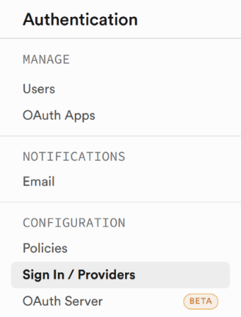
Make sure the "Confirm email" option is unchecked and click the [Save changes] button when done:
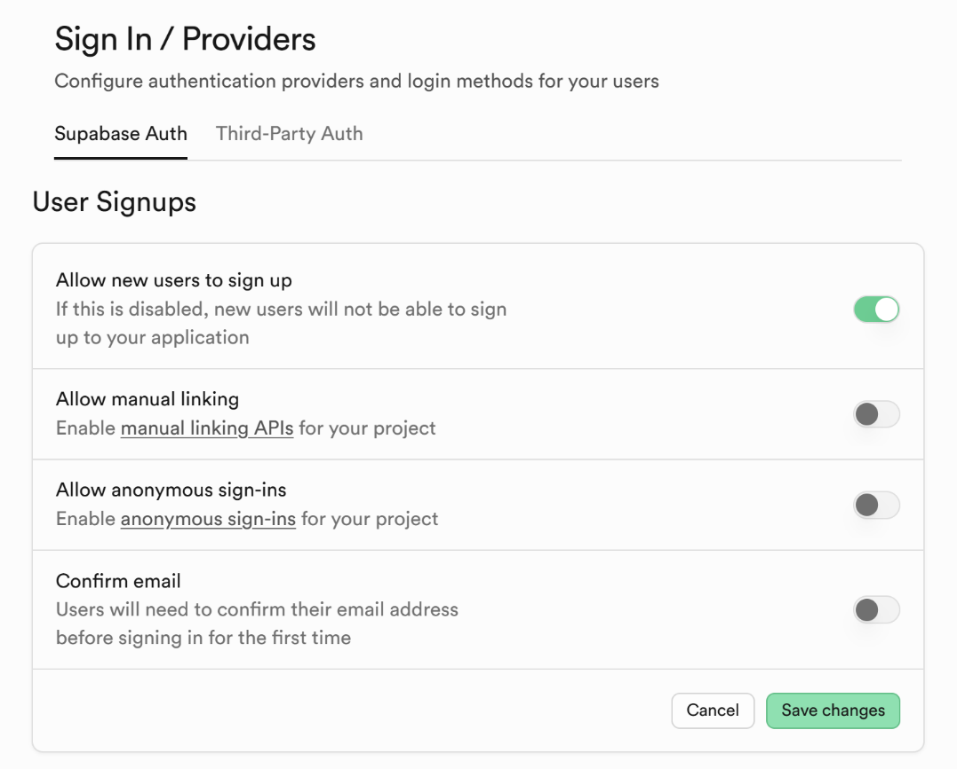

Step 2: Build the App
Build a mobile app with React Native + Expo + Expo Router to keep user bookmarks in Supabase.
- Bookmarks hold URL + description
- Screens: Home, Login, Register, Bookmarks, View / Add / Edit / Delete Bookmark
- Home screen: welcome text + login / register link -> redirect to Bookmarks screen
- Login / Register screens: standard login / register (email + password) with Supabase Auth
- Bookmarks screen: visualize the bookmarks, implement add / edit / delete
- Use separate screens for View / Add / Edit / Delete bookmark
- Create Supabase migrations to create configure and all needed DB tables. Keep migrations as local files
- Implement responsive design to support large screens (desktop Web) and mobile screens (smartphones)

Initialize an Expo Project
In a new workspace, use the Terminal and run the "npx create-expo-app bookmarkable" command.

Sample AI Prompt
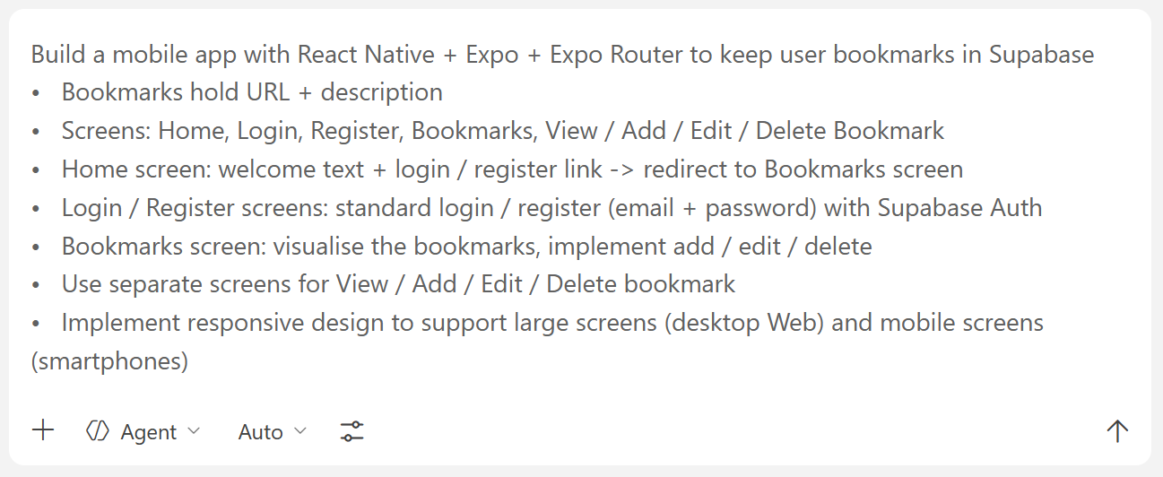

The Result

The App in the Browser
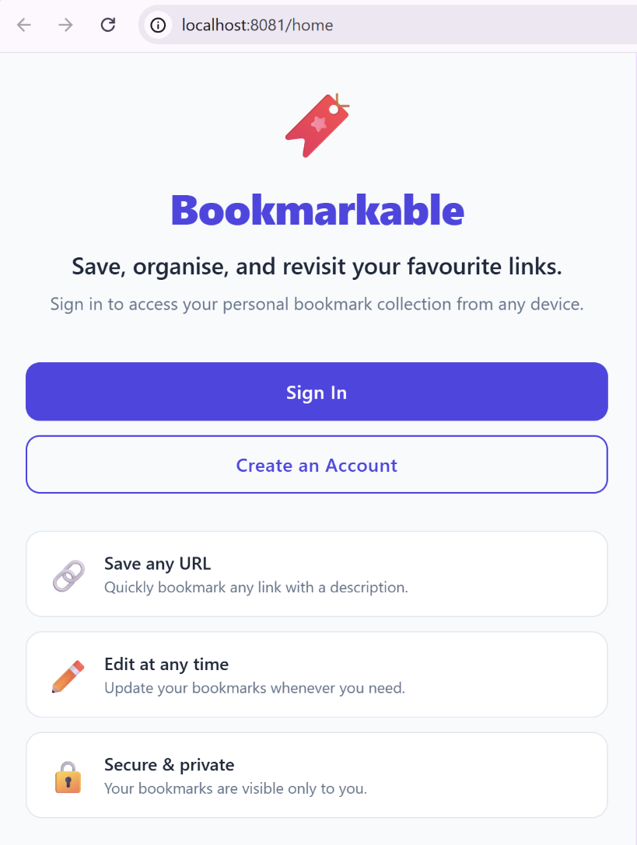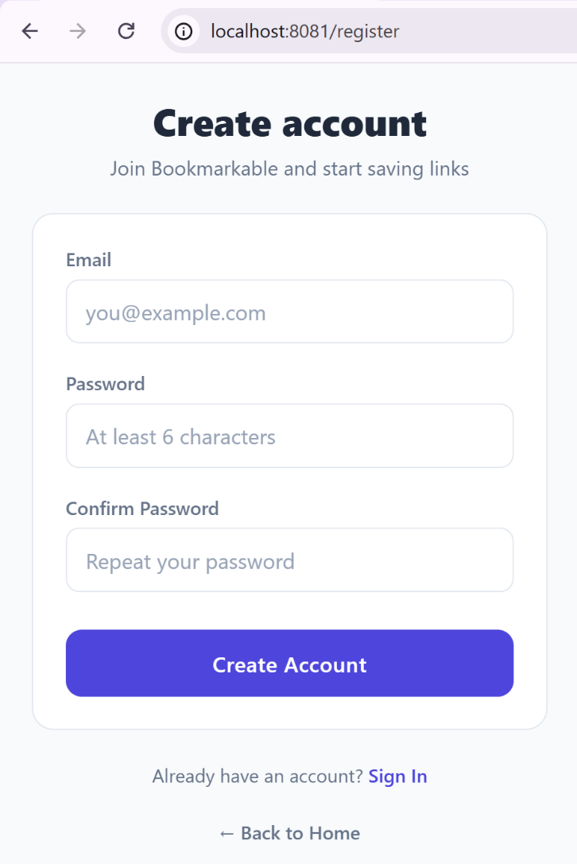
This is how the Dashboard looks when there is a logged in user:
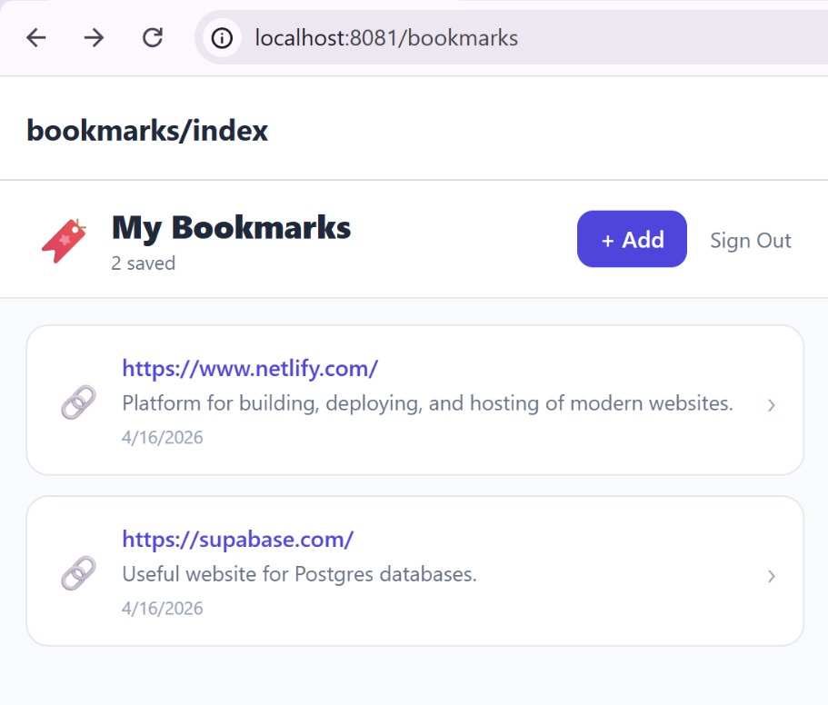

The App on a Smartphone

Home Page and Logged in Profile
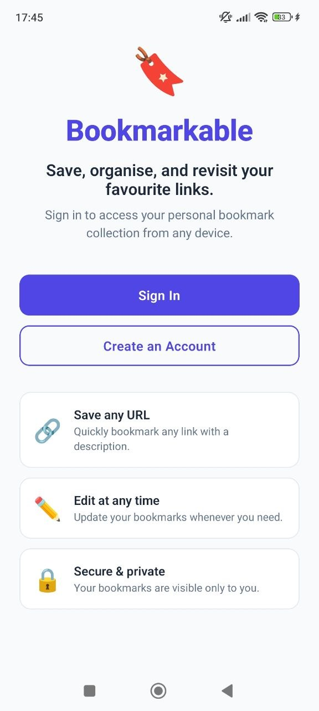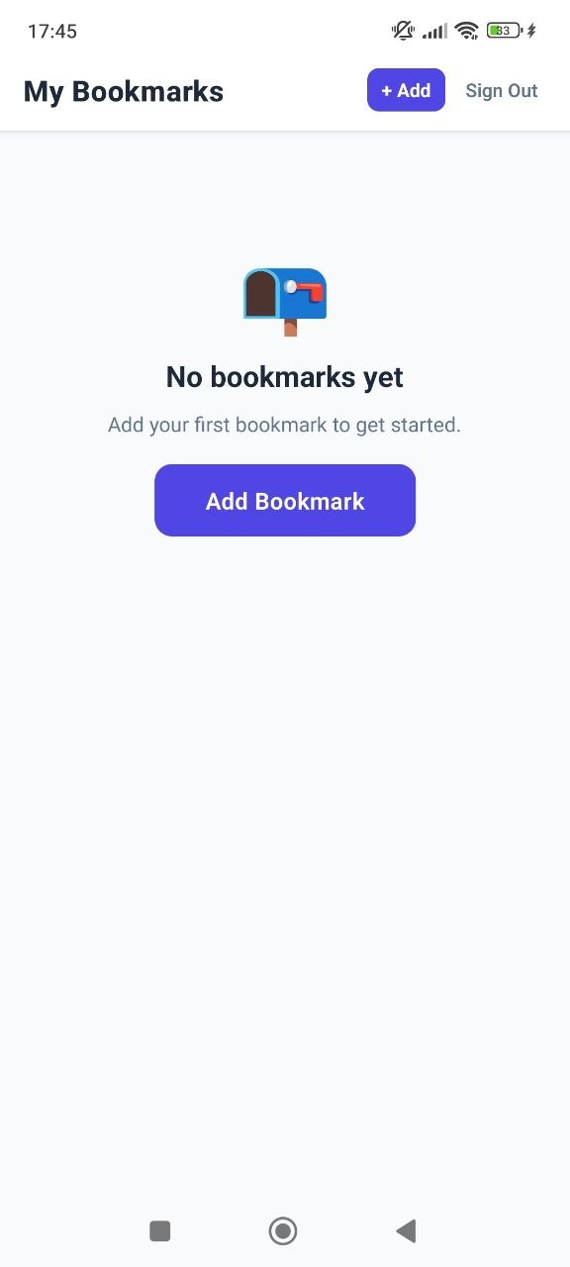

Adding Bookmarks
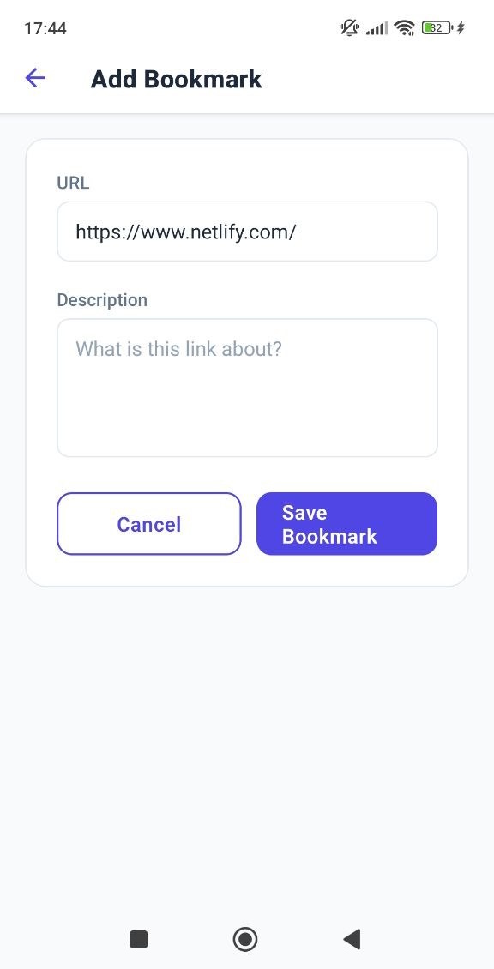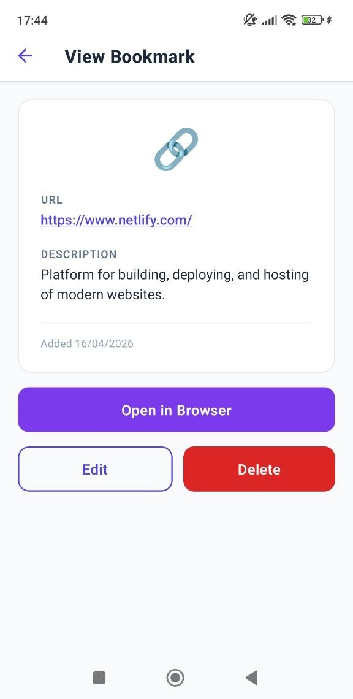

User Profile Overview and Logout Message
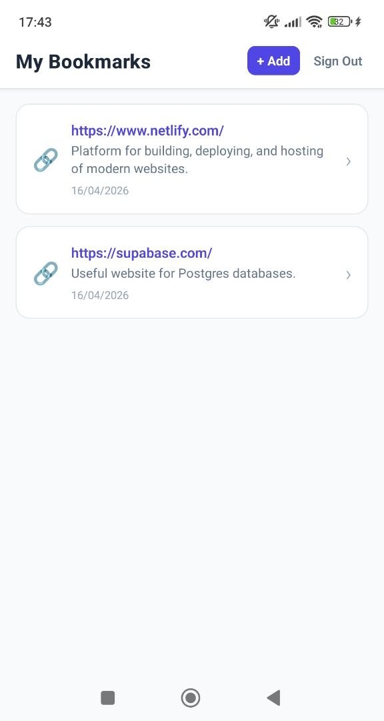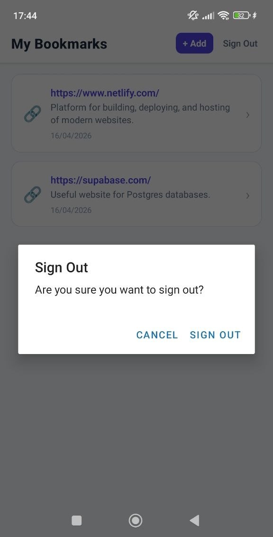

Password Vault Mobile App *
Build a simple Password Vault mobile app to securely store encrypted vault entries.

Step 0: Initialize a New Expo Project
In a new workspace, use the VS Code Terminal and run the "npx create-expo-app password-vault" command.

Step 1: Setup Supabase
- Create a new Supabase project
- Configure Supabase Auth, switch off email confirmation at user signup
- Connect a Supabase MCP to VS Code

Step 2: Build the App
Build a simple Password Vault mobile app to securely store encrypted vault entries:
- Use React Native, Expo, Expo Router and Supabase + data encryption libraries.
- Users log in with traditional credentials (username + password) in Supabase Auth.
- After register / login users provide a "master password", used to encrypt / decrypt the vault entries.
  - The master password is never sent out of the app, so that data can be decrypted only at the client-side, by users who know the correct master password.
- Vault entries are stored in Supabase, in encrypted format, with integrity metadata.
  - Keep in the user profile in Supabase a small, encrypted validation plaintext, e.g. "vault-check:v1", to check if the master password is correct.
  - After entering the master password, if the validation plaintext could be decrypted, the password is correct and the app will accept it. Otherwise, the password is incorrect, and the app will show an error.
- Database:
  - Apply DB migrations to define / edit database schema.
  - Keep a copy of all successfully executed migrations in a local folder as SQL scripts.
  - Vault entries consist of:
    - Title / URL (unencrypted)
    - User / email (optional, encrypted)
    - Password (hidden with show / hide button, optional, encrypted)
    - Comments (optional, encrypted)
    - Date created (unencrypted)
    - Last modified (unencrypted)
  - Use standard RLS policies to protect user's data.
- App user interface (UI):
  - The app should support Web browsers, Android and iOS
  - Home screen: display welcome text + link to login / register + initialize / unlock vault link
  - Show Vault Unlock link for existing accounts (when the master password was already assigned)
  - Show Vault Initialize link for new accounts (when the master password is still not assigned)
  - Login screen: standard user login (email + password)
  - Register screen: standard user registration (email + password)
  - Vault Unlock screen: enter a master password, verify it's correct and open the Vault screen
  - Vault Initialize screen: enter a master password and store the encrypted password validation plain text in the user profile, then open the Vault screen
  - Derive the master encryption key and keep it in a local variable in the app memory (this can be made more secure later)
  - Vault screen, available after the vault is successfully unlocked with the master password
    - Display all vault entries on the Vault screen
    - Implement add / edit / delete vault entry
    - Implement search (by title / URL)
    - Implement [Lock Vault] button to forget the master password and vault encryption key
  - Implement responsive design to support large screens (desktop Web) and mobile screens (smartphones)
- Encryption algorithms recommendations:
  - Use PBKDF2 algorithm to derive a master encryption key from the master password (it is not the most secure technology in the industry, but runs smoothly in cross-platform environments: Web / Android / iOS)
  - Use AES-256-GCM to encrypt / decrypt the vault entries (vault entries are stored in Supabase in encrypted form, using the master encryption key)
  - Use cross-platform JavaScript libraries to implement the key derivation and encryption algorithms

The Result

The Database
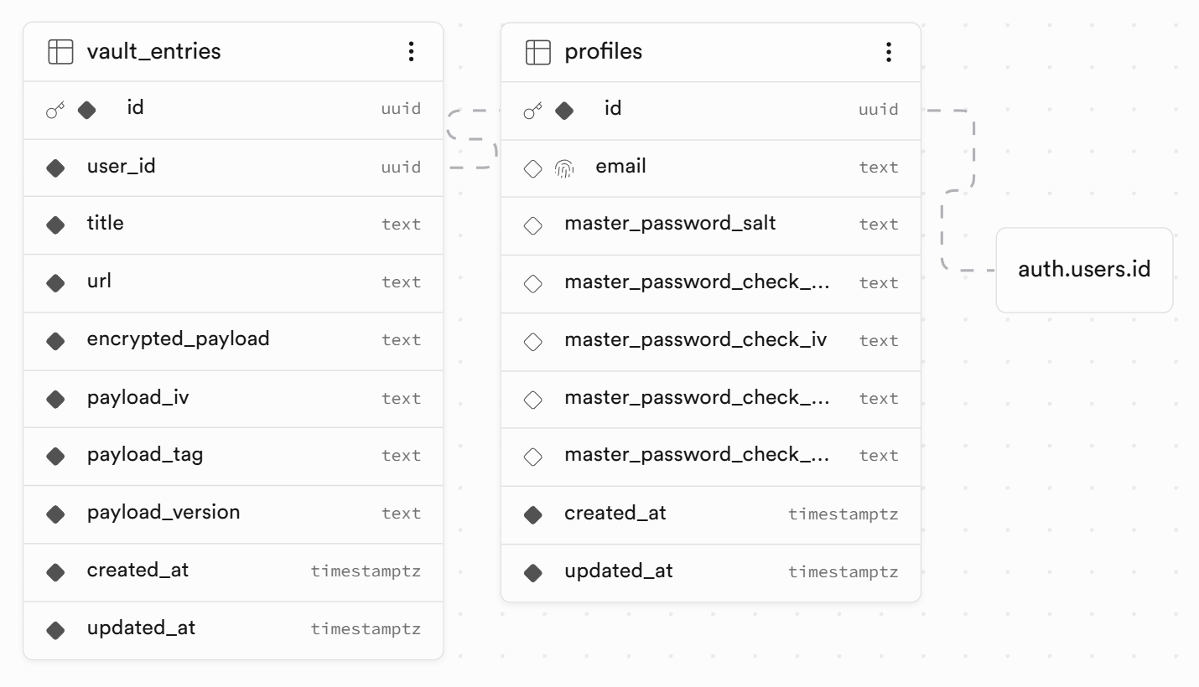

The App in the Browser
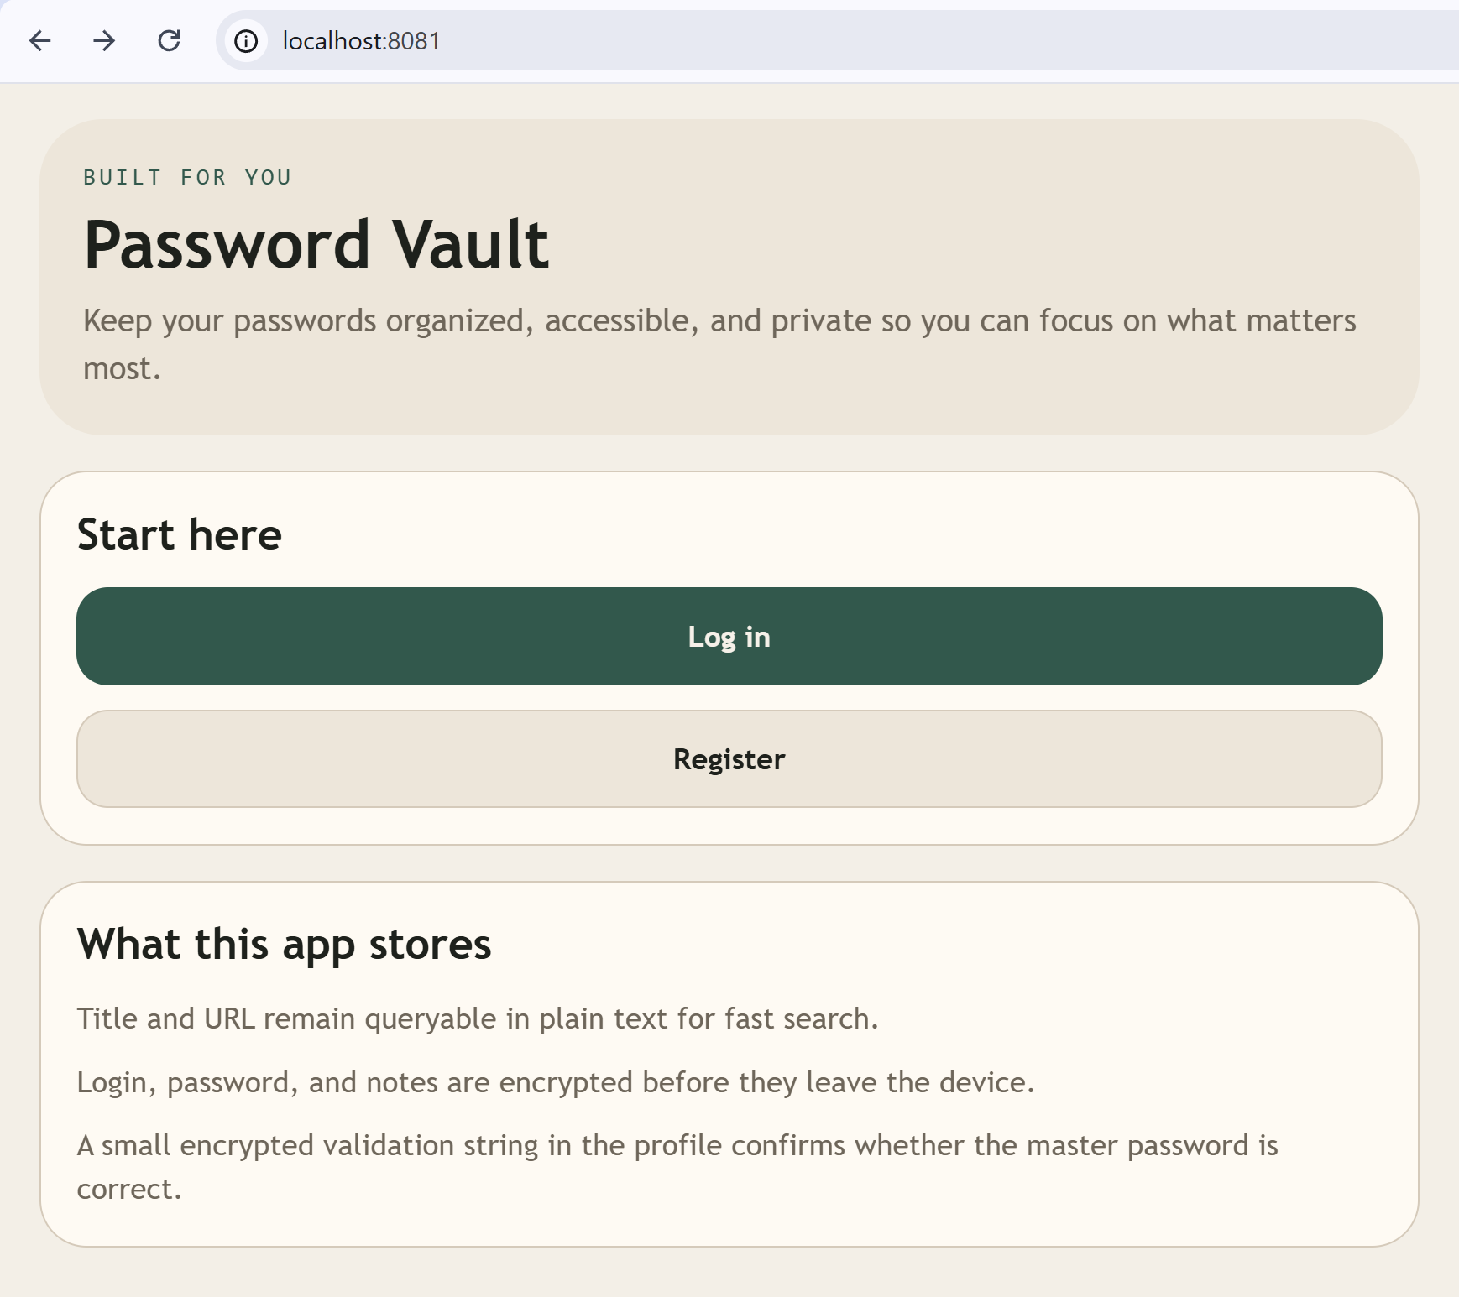

Logged In the Browser
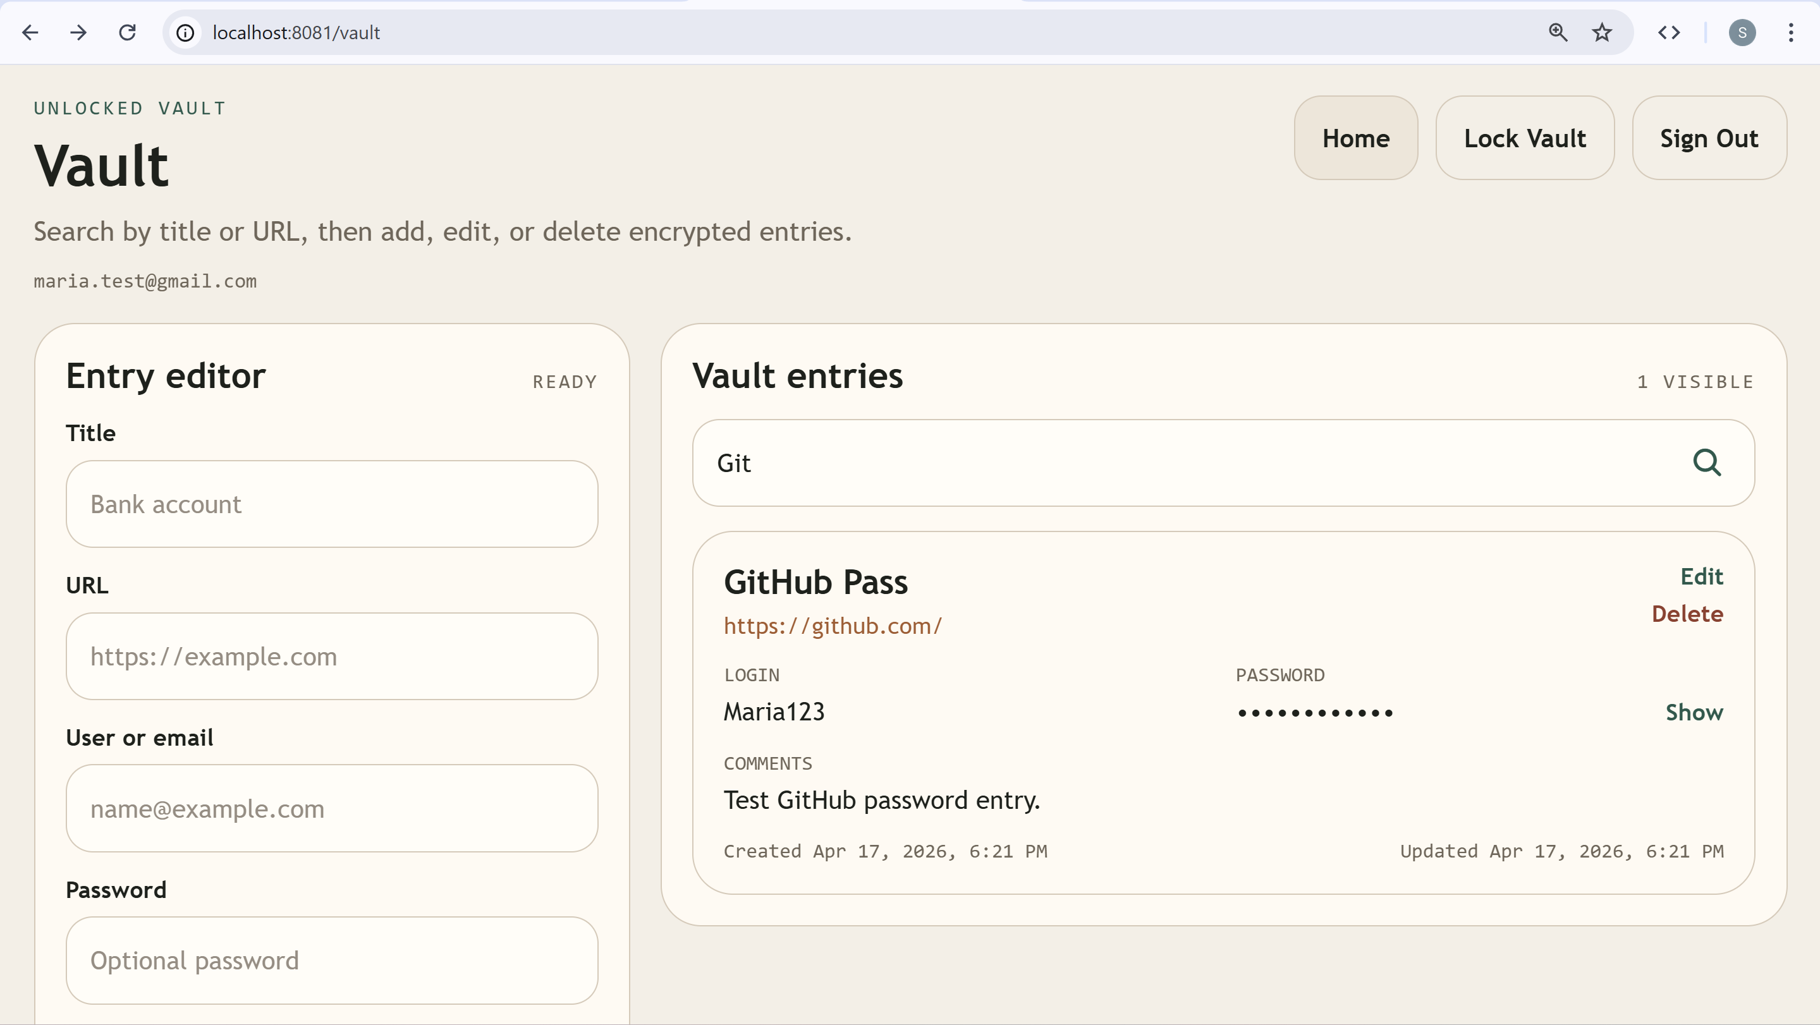

The App on a Smartphone
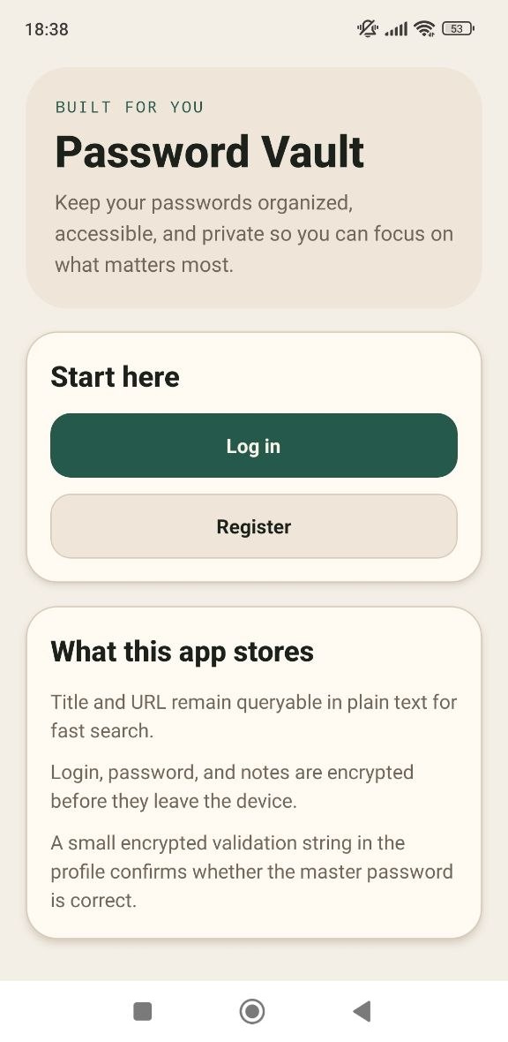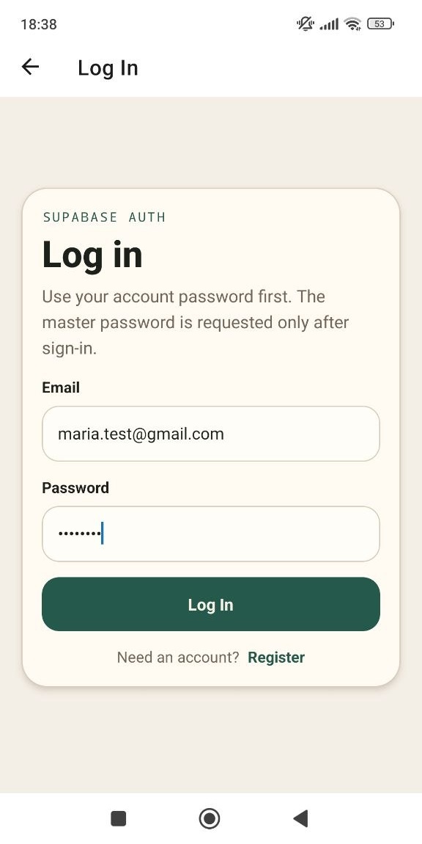

The Vault
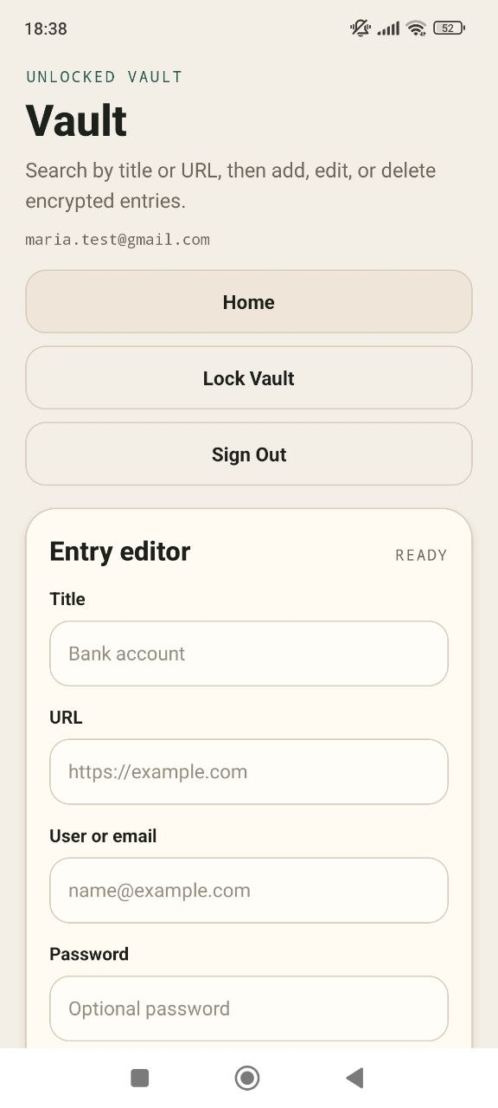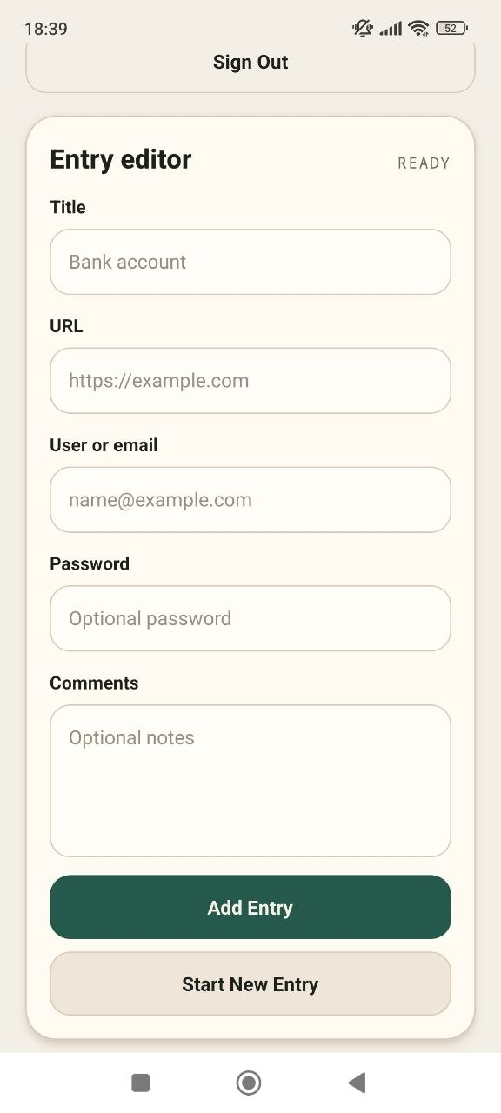
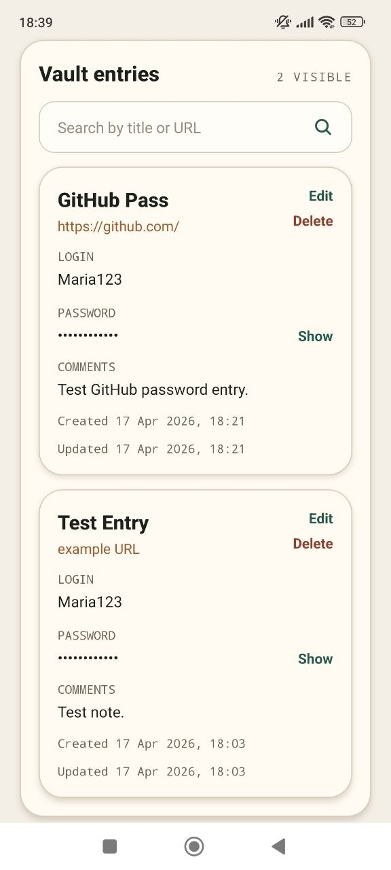

Error 1: Missing Supabase Credentials
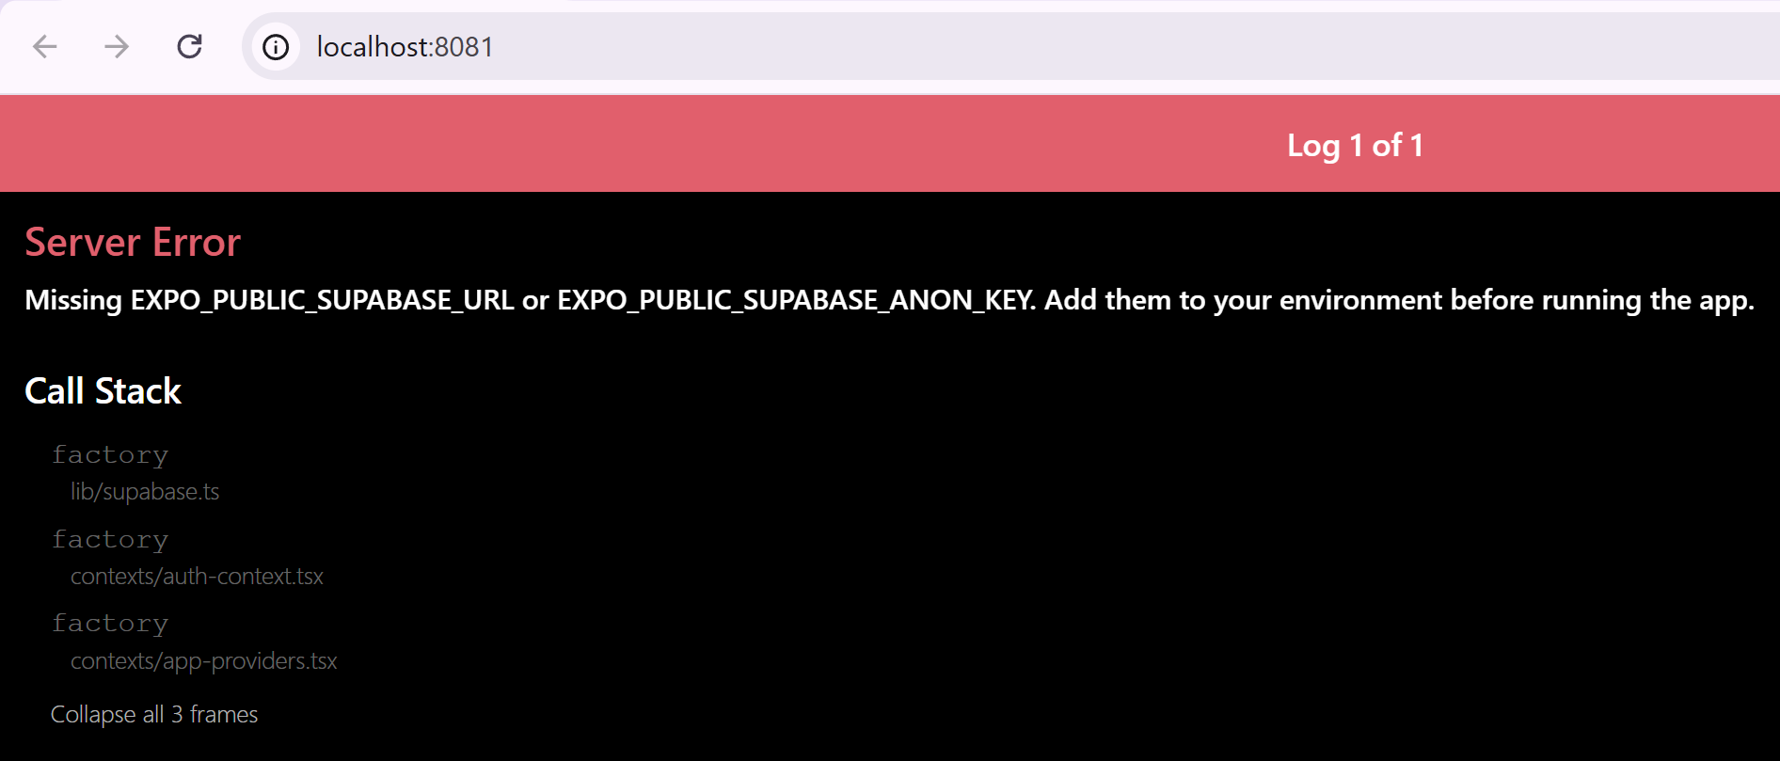

Explanation
The issue arises because the app relies on an external service (Supabase) that requires specific configuration values (a project URL and a public API key). These values should not be hardcoded in the source code but instead provided via a `.env` file as environment variables.
Sometimes Copilot may make these values hardcoded or not strictly validated, so the app could start without errors even if they are missing.
In other cases, the implementation is stricter and explicitly requires these variables at startup; if they are missing, the app throws an error to prevent running in an invalid state.
You can check the code for such conditions in `lib/supabase.ts`. They usually look like this:
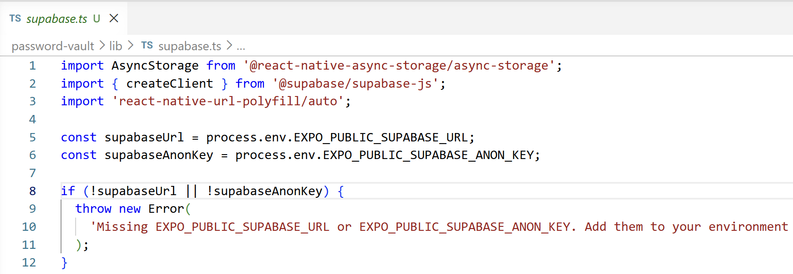
Tools like GitHub Copilot cannot fill them in automatically because they are unique, sensitive credentials tied to your specific project.

Solution
In the generated files there should be one called `.env.example`. It should contain sample values like this:
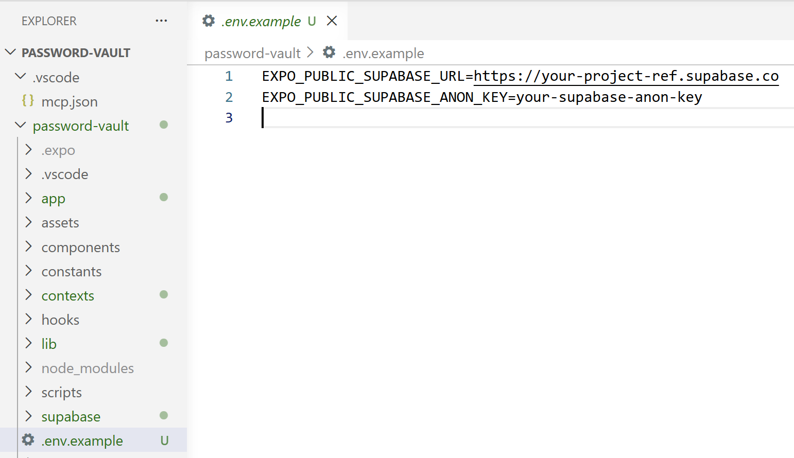
Manually create a new file and call it `.env` only. Copy the content from the example one and put the project URL and Anon Key there.
To find the project URL, open your project, go to [Project Overview] -> [Copy] -> Select [Project URL]
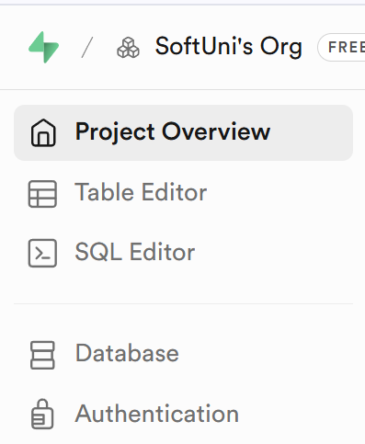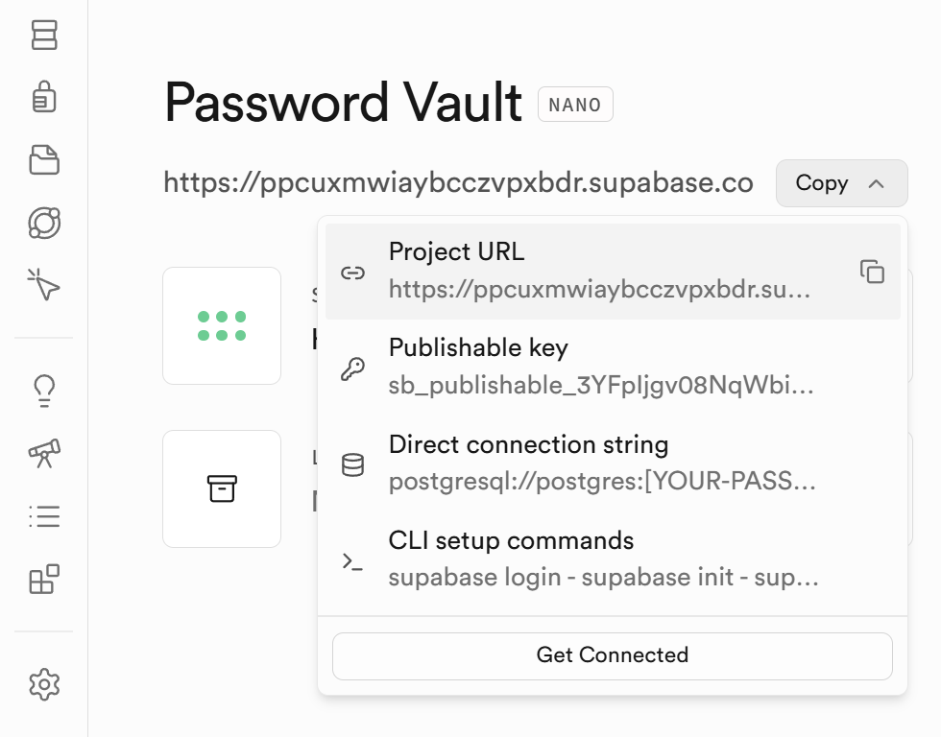
To find the Anon Key go to Project Settings -> API Keys:
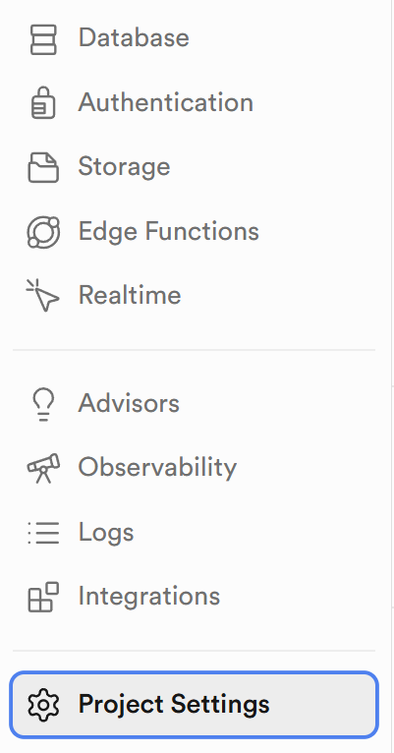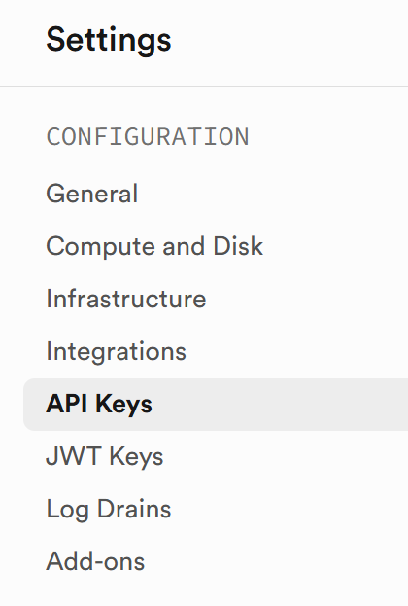
Then select Legacy anon, service_role API keys and copy the first code:
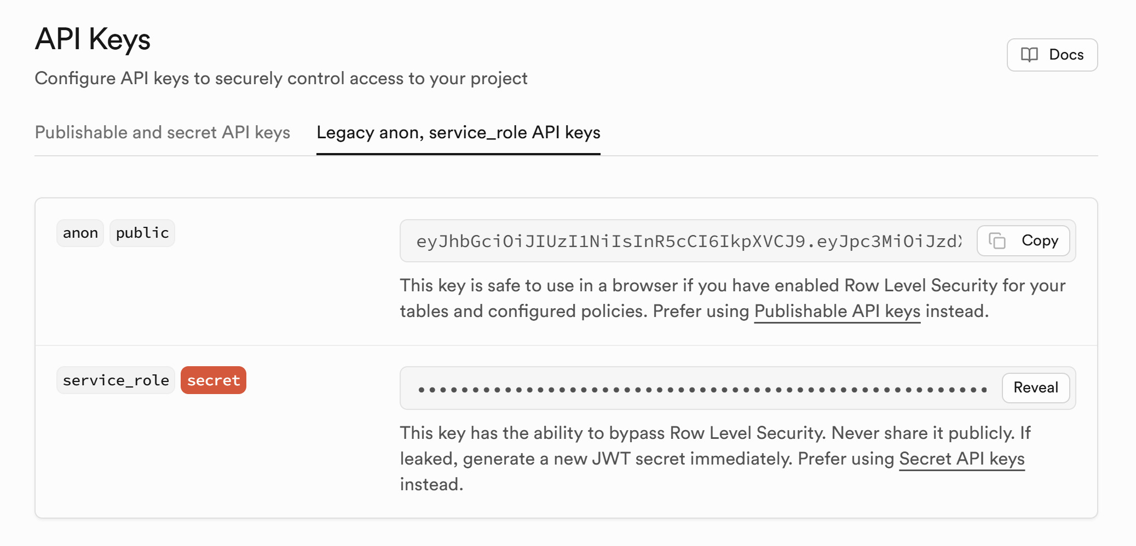
The file should look like this:
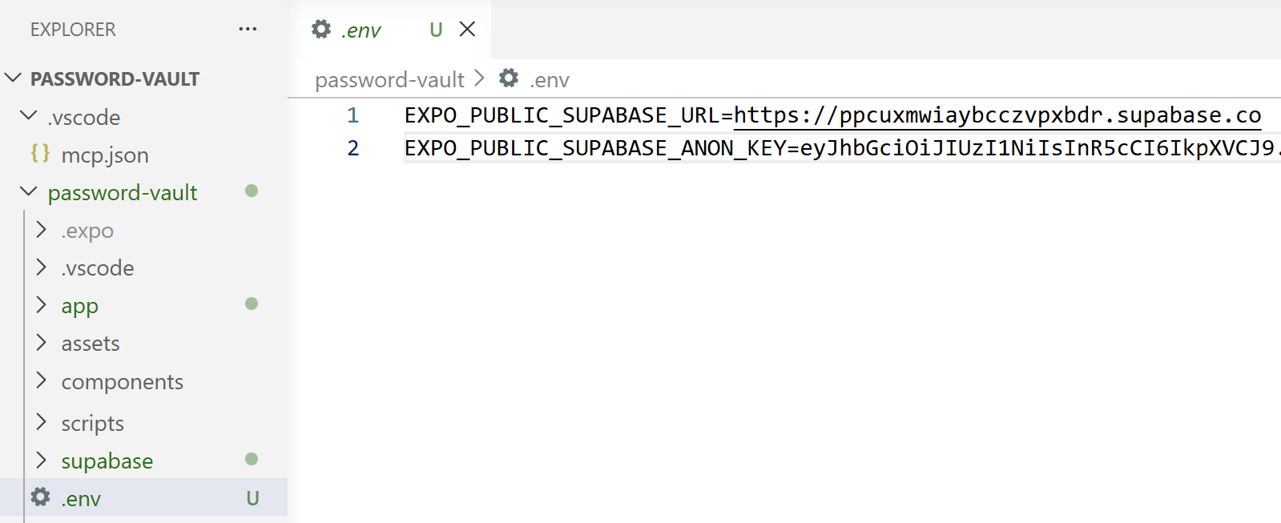

Error 2: The App Works Only in the Browser
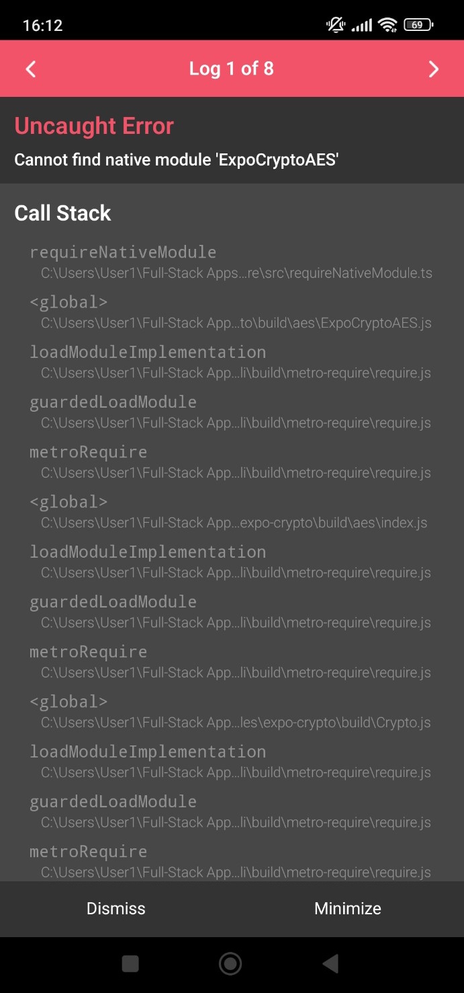

Explanation
The error means the app is trying to use a native module (ExpoCryptoAES) that does not exist in Expo Go.
It works in the browser because web crypto APIs are available there, but on mobile these features require native code.
So the app crashes because the required native module is missing.

Solution
Run the following prompt in Copilot:
Fix this Expo app error:
"Cannot find native module 'ExpoCryptoAES'"
Constraints:
Must work in Expo Go AND web
No custom dev builds
No native modules
Tasks:
Remove or replace any AES/native crypto usage
Use only pure JS or Expo-supported APIs
Add Platform.OS checks if needed
Ensure no runtime crashes

Error 3: AsyncStorageError: Native module is null
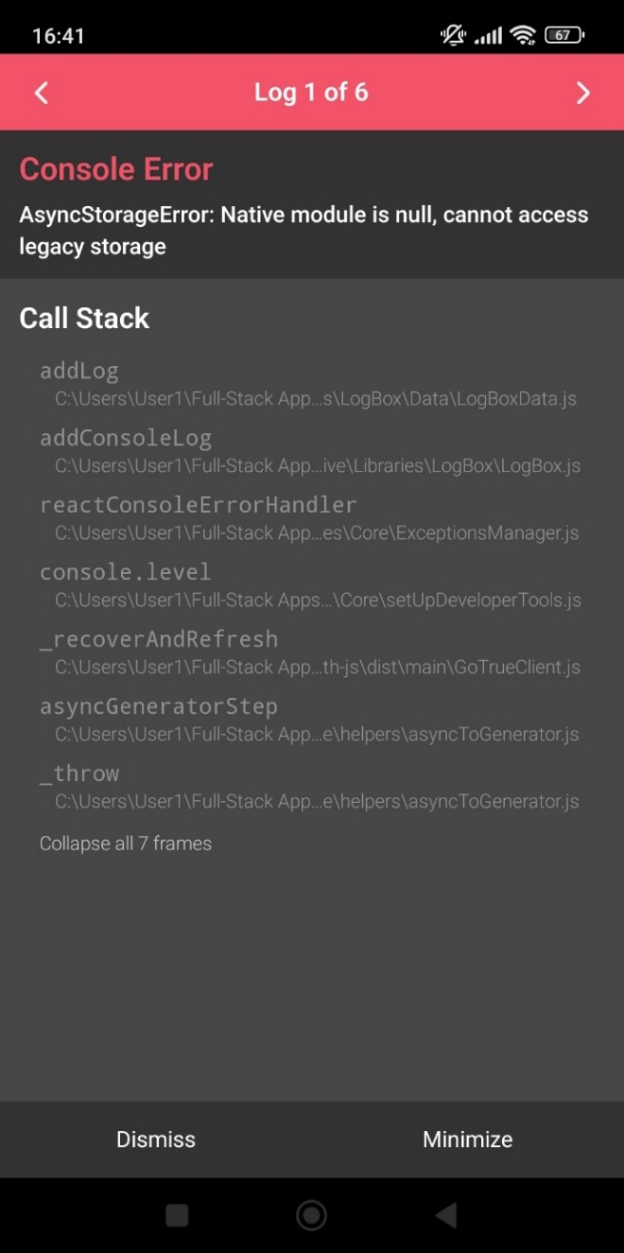

Explanation
This issue is related to the previous one, and it means a package has not been installed or linked properly.

Solution
Run the `npx expo install @react-native-async-storage/async-storage`command and then start restart the app and clear the cache with this command ` npx expo start -c`.

